Overview of IIT Palakkad
IIT Palakkad is a public autonomous engineering and research institute in Palakkad, Kerala, India. It is one of the 23 Indian Institutes of Technology (IITs) and was established in 2015 as an Institute of National Importance by the Government of India.
Rankings and Recognition
IIT Palakkad ranked 69th under the ‘Engineering’ category by the National Institutional Ranking Framework (NIRF) Ranking 2023.
Vision
Purpose
To create knowledge; to communicate knowledge; and to apply knowledge for the benefit of society.
To nurture lifelong learners who have a rigorous foundation, a passion for innovation, strong ethical values and a recognition of their social responsibility.
To be home to the best minds from across the globe.
Core Values
We are a happy and vibrant community founded on reason and compassion, driven by curiosity, creativity and a desire to be agents of change.
We cherish a sense of belonging towards the Institution.
We foster diversity in composition and thought, boundaryless inquiries and interactions, and free and independent thinking.
We espouse an ecologically and socially responsible way of life.
Envisioned Future
We envision being a globally recognized institution at the forefront of education, research, and technology development, having strong ties with industries and other academic institutions.
We envision being an inclusive and diverse community on a sustainable and green campus, actively engaged with our neighbourhood.

Objectives and Scope of the Project

Objectives:
- Power Electronics Converters: Design and analysing power electronics converter links.
- Converters Analysis: Numerical calculations and analysis for various converters including buck, boost, and buck-boost converters, flyback, forward, and push-pull converters.
- Spreadsheet Development: Create a comprehensive formula-based spreadsheet for converter calculations.
- Simulation: Simulate the converters using LT Spice to validate designs and calculations.
- Gate Driver Circuit Design: Design the NCP51820 Onsemi gate driver circuit.
- Component Creation: Develop and integrate GaN 3R2-100CBE components.
- Schematic and PCB Design: Created detailed Altium schematics and PCB routing.
Scope:
- Research and Development: Focus on advancing the design and efficiency of power electronic converters.
- Practical Applications: Apply theoretical knowledge to practical designs and simulations.
- Tool Proficiency: Gain expertise in tools like LT Spice and Altium for simulation and schematic design.
- Component Integration: Learn the process of creating and integrating advanced components such as GaN transistors and Gate drivers into circuit designs.

Chapter – 1
Power Electronics
  - Introduction to Power Electronics
Power electronics is a crucial field in electrical engineering, focusing on the efficient conversion and control of electrical power using electronic devices. It encompasses the design, analysis, and implementation of circuits that convert electrical energy from one form to another, which is essential for various applications ranging from consumer electronics to industrial systems and renewable energy sources.
The field of power electronics has evolved significantly over the years, driven by advancements in semiconductor technology, which have enabled the development of more efficient, reliable, and compact power converters. These converters include rectifiers, inverters, choppers, and various types of DC-DC converters such as buck, boost, and buck-boost converters.
Power electronics plays a pivotal role in modern technology, facilitating the control of power flow and enhancing the performance of electrical systems. It enables efficient energy conversion in a wide range of applications, including power supplies for electronic devices, electric vehicles, renewable energy systems, and industrial automation.
The importance of power electronics lies in its ability to improve energy efficiency, reduce losses, and provide precise control over electrical power. As energy demands continue to rise and the push for renewable energy sources intensifies, the role of power electronics in developing sustainable and efficient energy solutions becomes increasingly vital.

  - Power Electronics Converters

Buck Converter:
A buck converter is a type of DC-DC converter that steps down the input voltage to a lower output voltage. It is widely used in applications where a stable and lower voltage is needed from a higher voltage source, such as in power supplies for electronic devices. The buck converter operates by switching a transistor on and off, storing energy in an inductor, and releasing it at a controlled rate to the load.

Boost Converter:
A boost converter is a DC-DC converter that steps up the input voltage to a higher output voltage. It is useful in applications where an increase in voltage is required, such as in battery-powered devices needing a higher operating voltage than the battery provides. The boost converter works by storing energy in an inductor when the switch is closed and releasing it to the load through a diode when the switch is open.

Buck-Boost Converter:
A buck-boost converter combines the functionalities of both buck and boost converters, allowing it to either step up or step down the input voltage based on the requirements. It is versatile and used in applications where the output voltage needs to be adjusted above or below the input voltage. The buck-boost converter can invert the voltage, making it useful in a variety of power management scenarios.

Flyback Converter:
The flyback converter is a type of DC-DC converter that uses a transformer to store energy when the switch is on and transfer it to the output when the switch is off. It can provide isolation between the input and output, which is crucial in applications requiring safety and noise reduction. Flyback converters are commonly used in low-power applications such as power supplies for televisions and other consumer electronics.

Forward Converter:
A forward converter is another type of isolated DC-DC converter that uses a transformer for energy transfer. Unlike the flyback converter, the forward converter transfers energy to the output during the switch's on-state. It is typically used in higher power applications and offers better efficiency and regulation compared to the flyback converter. Forward converters are found in industrial power supplies and telecom equipment.

Chapter - 2
Software Setup and Tools
2.1. LTspice Simulation Software

LTspice: A Powerful, Free SPICE Simulator
LTspice is a powerful, fast, and free SPICE simulation software created by Linear Technology Company, now known as Analog Devices. It encompasses a graphical schematic capture interface that lets users to probe the integrity of specific circuits and the creation, of course, of simulation results according to the settings of simulation that the user will see through a built-in waveform viewer, through the selection of different modes and methodologies that are aimed to investigate the electrical circuits in question.
Key Features and Benefits of LTspice
Fast and Unlimited Simulation Capabilities: LTspice outperforms many paid SPICE simulation options, with an unlimited number of nodes and the ability to rapidly simulate complex analog circuits.
Extensive Model Library: LTspice comes with over 1,100 macromodels for Analog Devices products, as well as a library of passive devices to aid circuit design.
Optimized for Power Electronics: LTspice is particularly well-suited for simulating switching mode power supplies (SMPS), with features like steady state detection and efficiency/power computations.
Free and Widely Used: As a free SPICE simulator, LTspice is widely adopted by electronics engineers and students. It provides a cost-effective solution for circuit prototyping and analysis.

Advanced LTspice Capabilities
Beyond the basic simulation capabilities, LTspice offers several advanced features:
Importing Third-Party Models: LTspice allows users to incorporate external SPICE models, enabling the simulation of a wider range of components.
Behavioral Sources and Expressions: LTspice supports the use of behavioral sources and the evaluation of mathematical expressions, providing greater flexibility in circuit modeling.
Temperature Analysis: LTspice enables the simulation of circuits under varying temperature conditions, allowing designers to assess the impact of temperature on circuit performance.

2.2. Altium Designer for PCB Design
Developer : Altium Limited
Initial Release : 2005
Latest Version : 23.11.1 (16 November 2023)
Origins : Evolved from DOS-based PCB design tool 'Protel PCB' launched in 1985
Main Functional Areas: Schematic capture, 3D PCB design, FPGA development, data management
Key Features : 3D visualization of PCB assembly, integration with component distributors
Altium 365 : Cloud-based platform connecting stakeholders in PCB design

Altium Designer is a powerful, all-in-one PCB design software that combines schematic capture, layout, and manufacturing documentation into a single intuitive interface. With its unified data model and advanced features, Altium Designer streamlines the entire design process from start to finish.
Key features of Altium Designer include:
- Precision and speed for meeting challenging design requirements and tight timelines
- Integrated SPICE simulation, power analysis, and signal integrity checks
- Support for complex designs such as HDI, high-speed, multi-board, and rigid flex
- Seamless collaboration across locations with Altium 365, enabling co-design and optimized resource allocation
- Efficient routing of high-speed electronics and dense layouts at any angle with an industry-leading interactive routing engine
- Accurate design and visualization of HDI structures for improved performance
- Secure, version-controlled data management and real-time component information with Altium 365, reducing risks and enhancing manufacturability decisions

Chapter – 3
Fundamentals of Power electronics simulations in LT spice
Half-Wave Rectifier
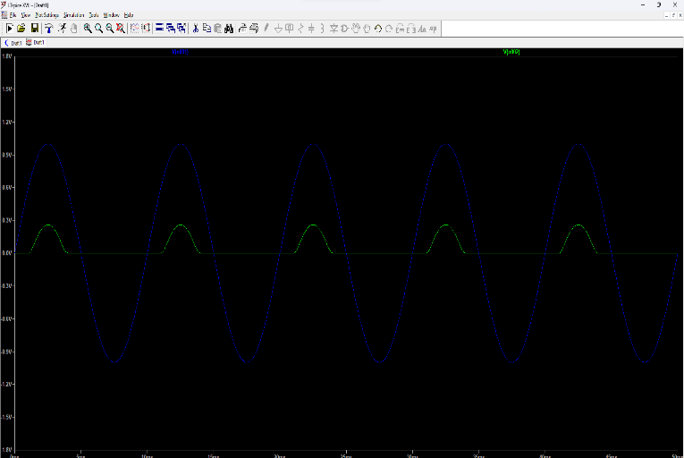
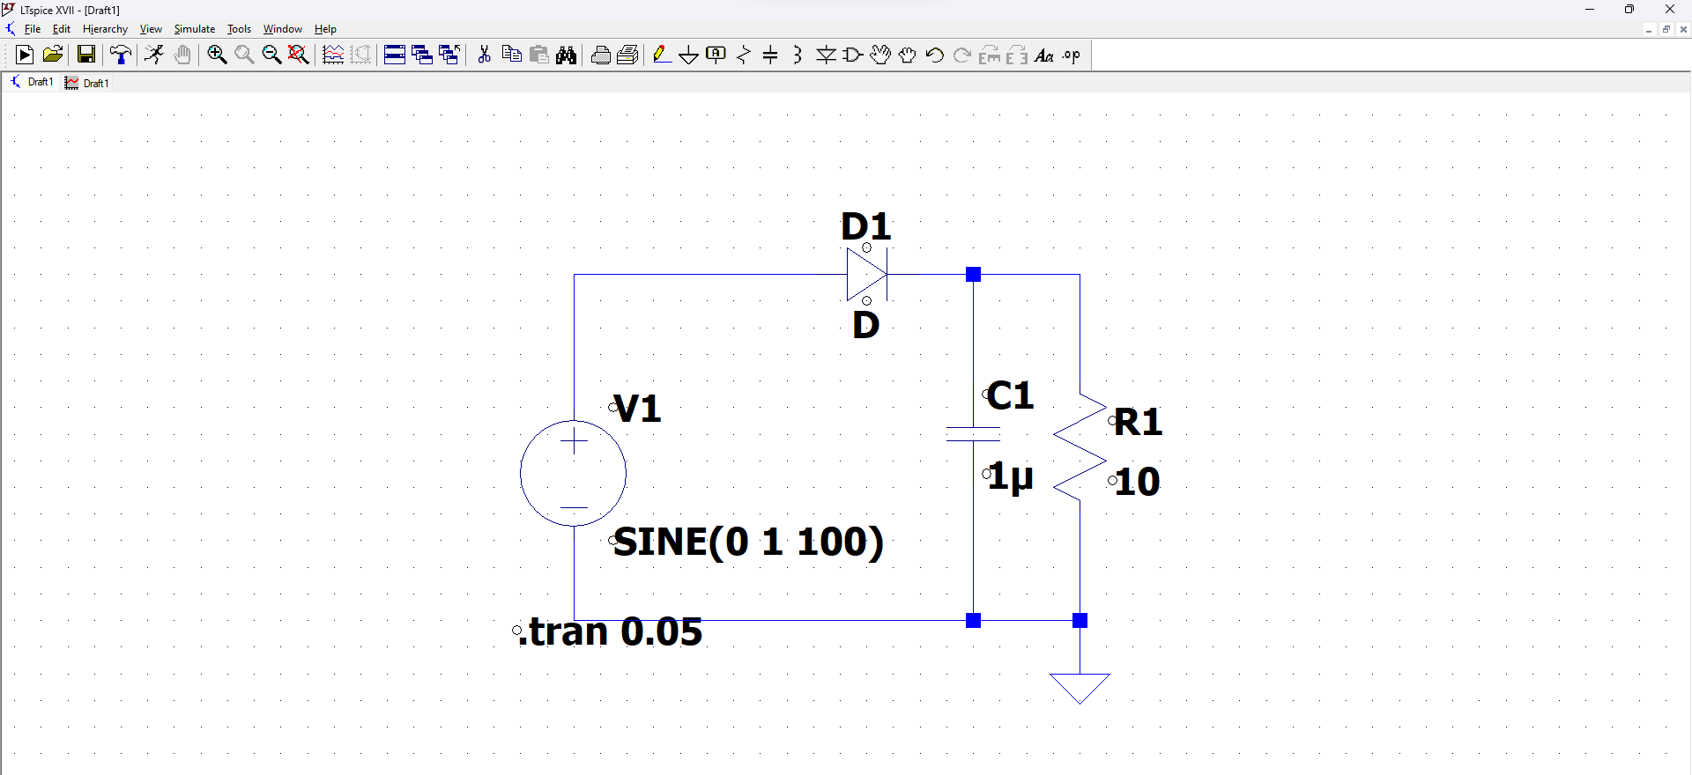
Full wave Rectifier
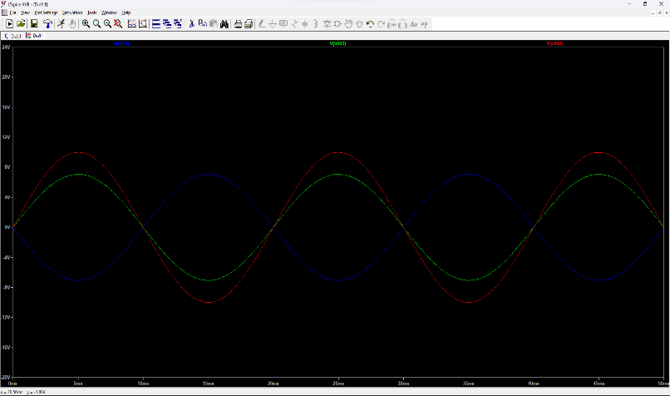
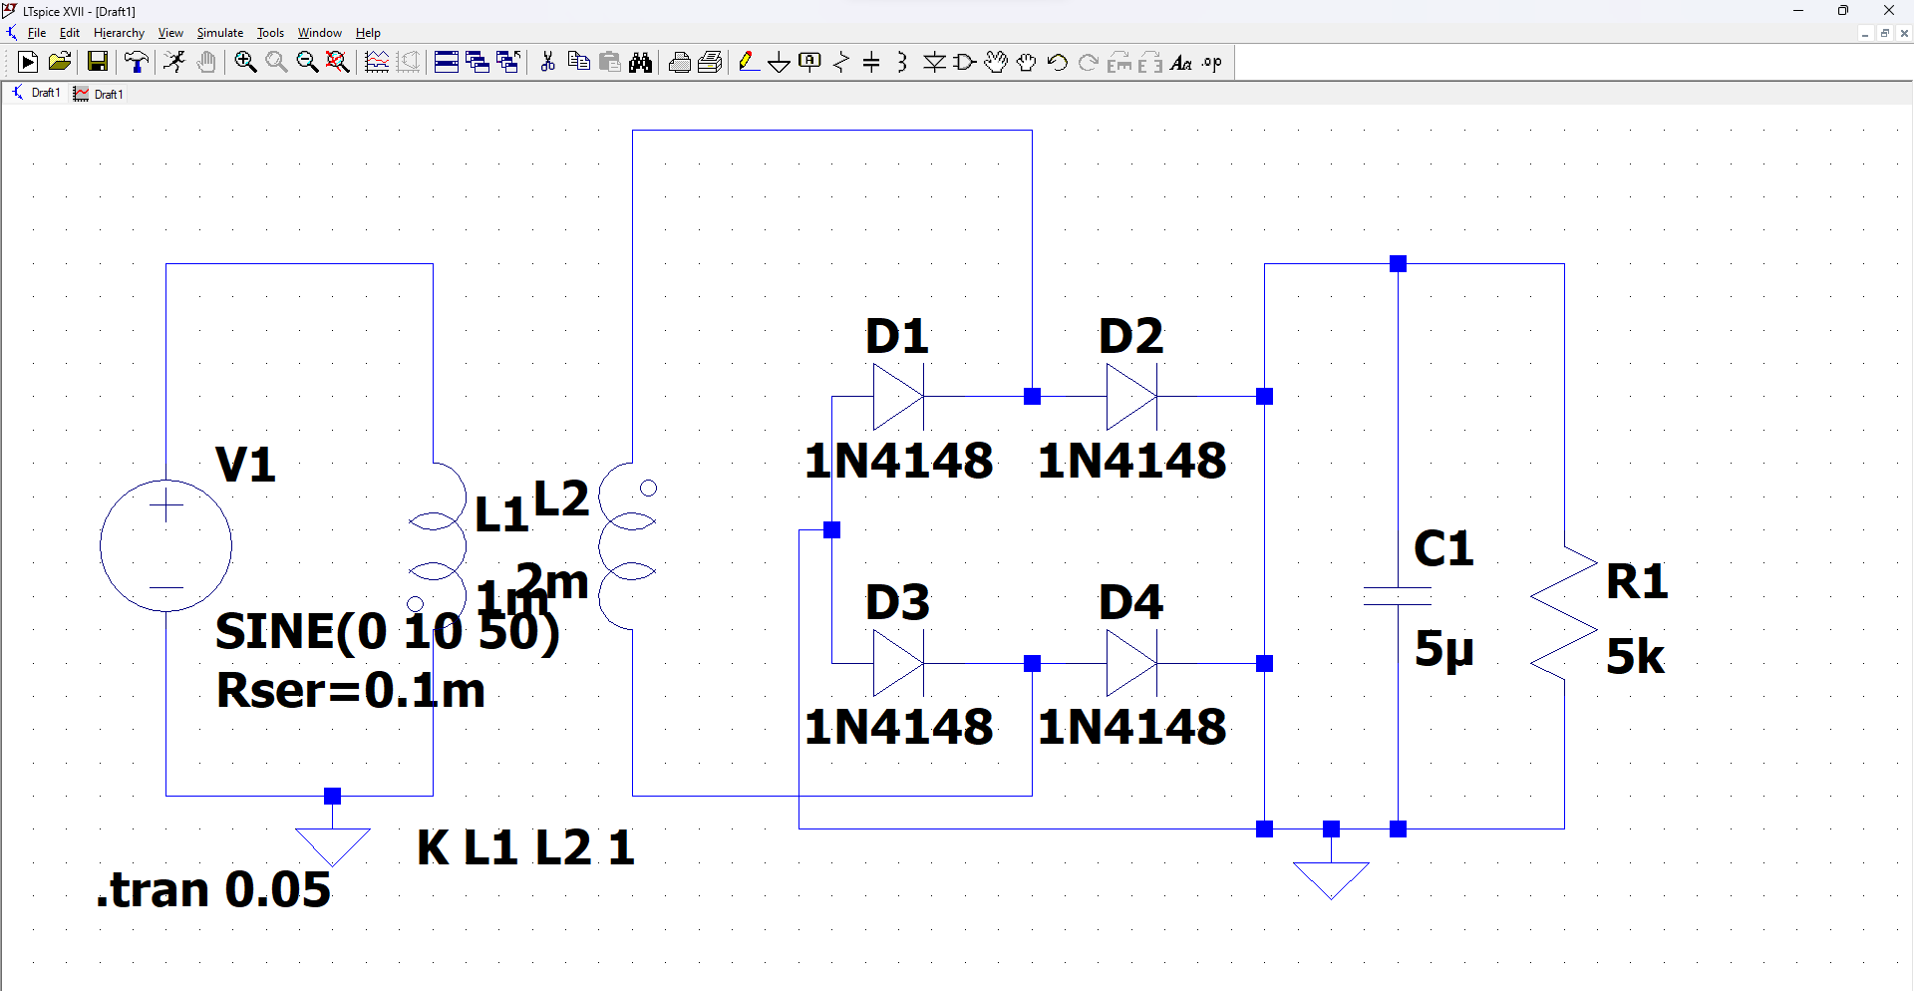
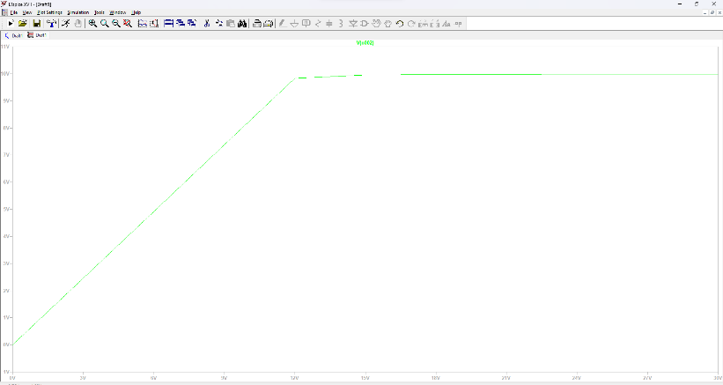
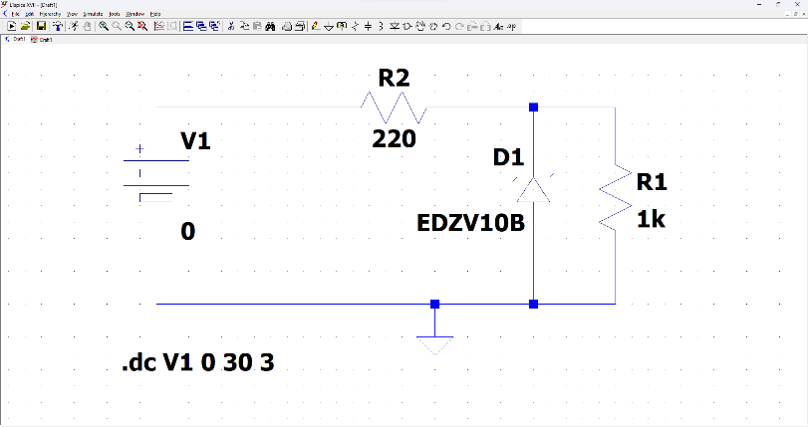
Zener Diode

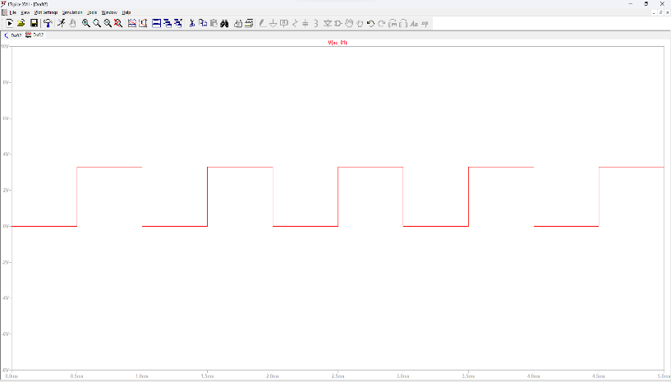
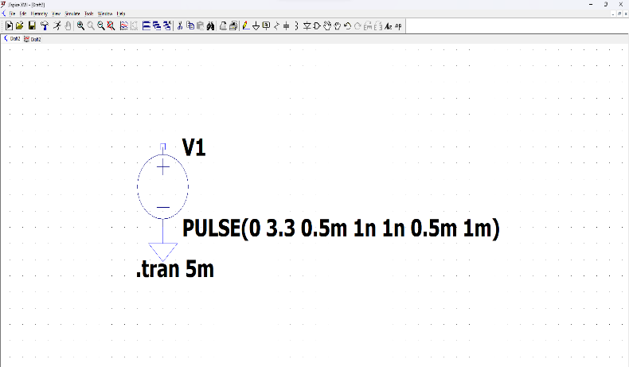
Pulse generation Voltage (Voltage source)

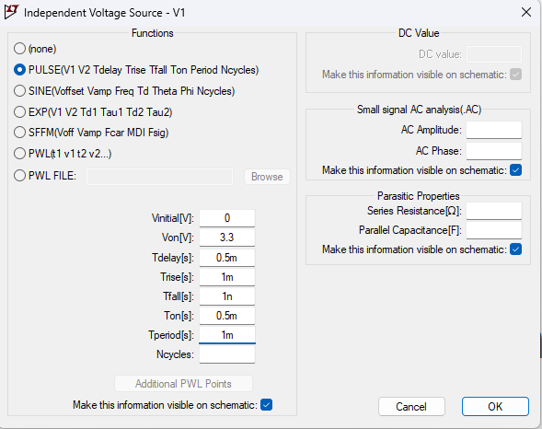

Pulse Generation – Triangular using Voltage source
Half Cycle
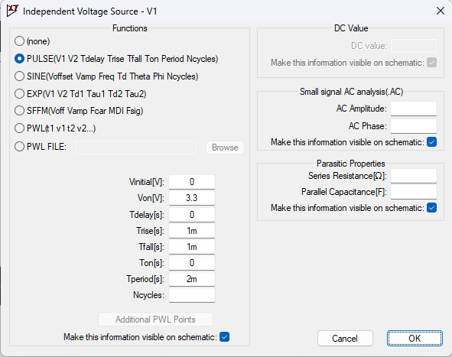
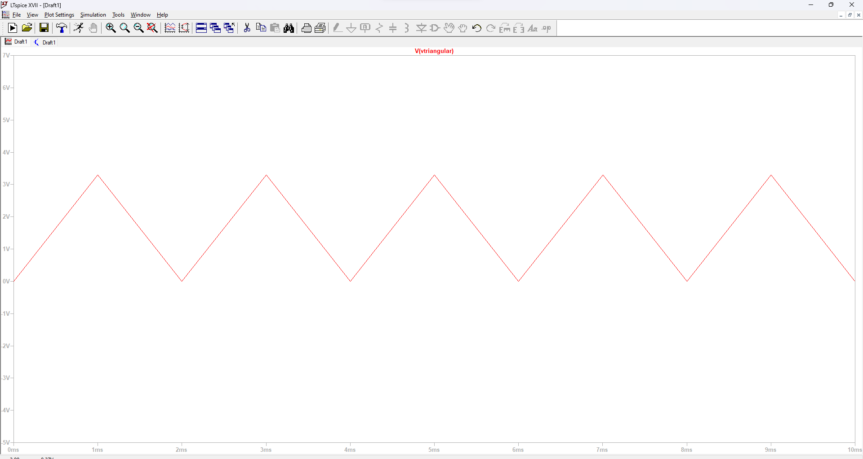

Full Cycle
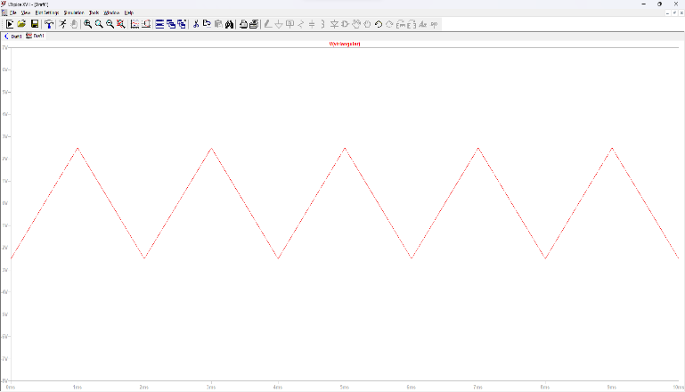
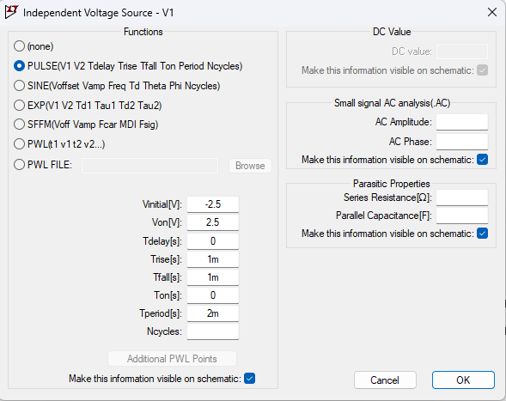
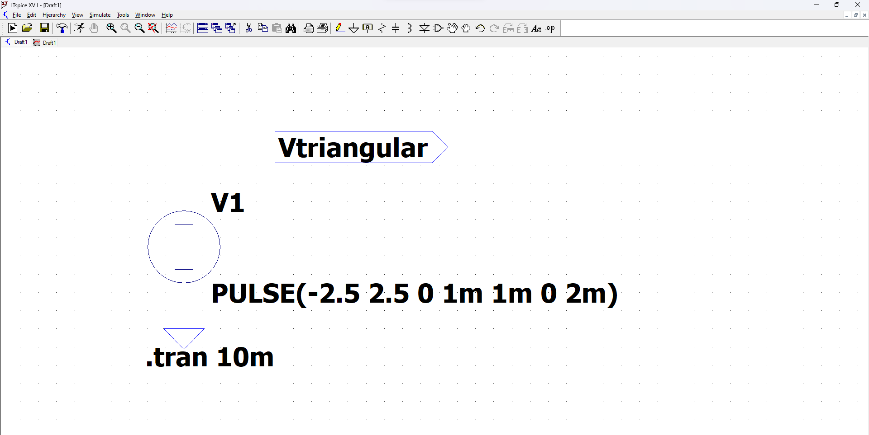

Pulse Generation – Sawtooth using Voltage source
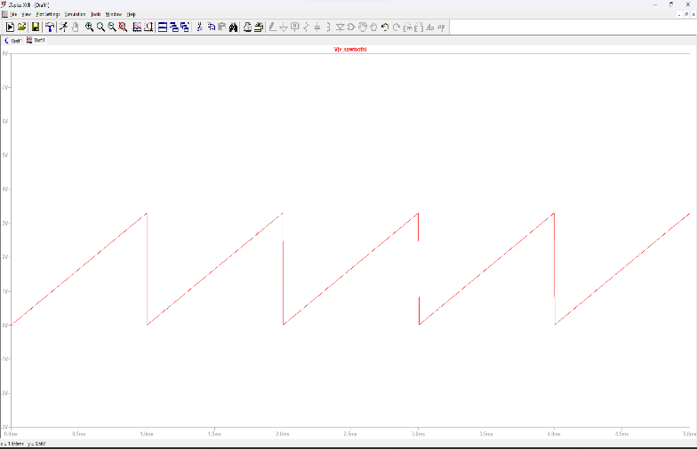
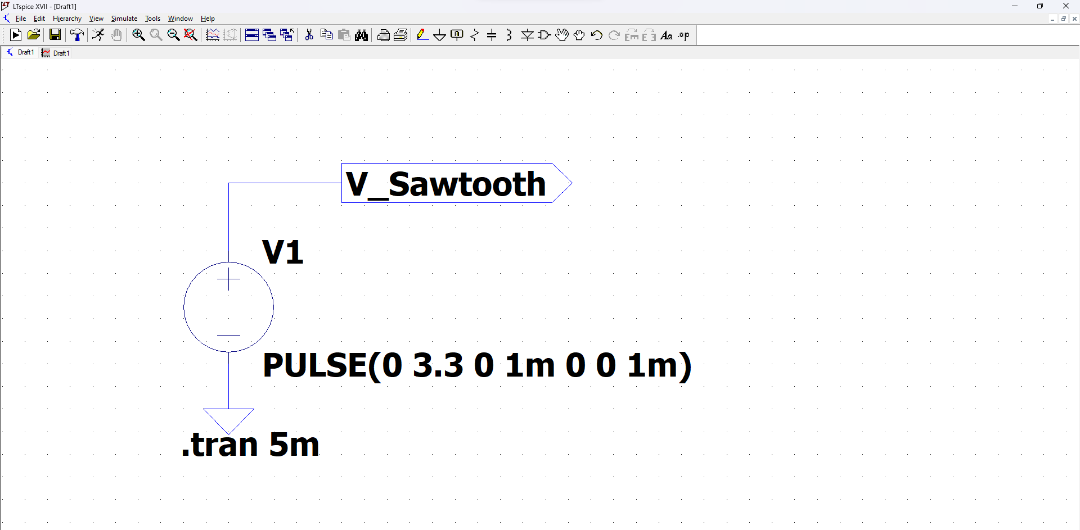
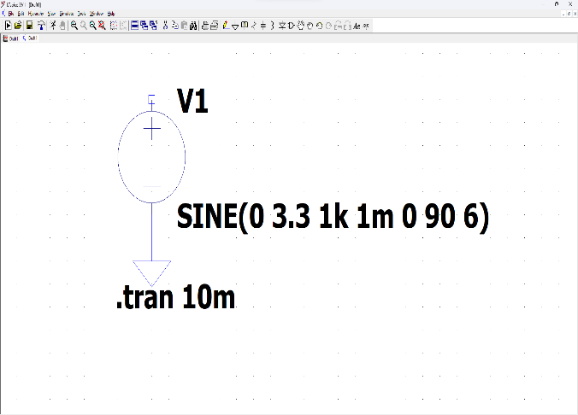
Pulse Generation using sign wave
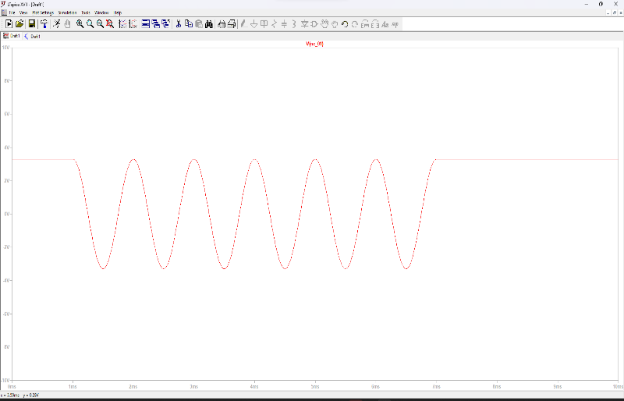
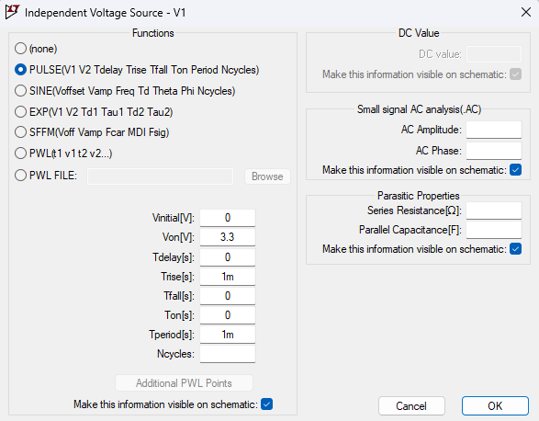

Voltage control switching
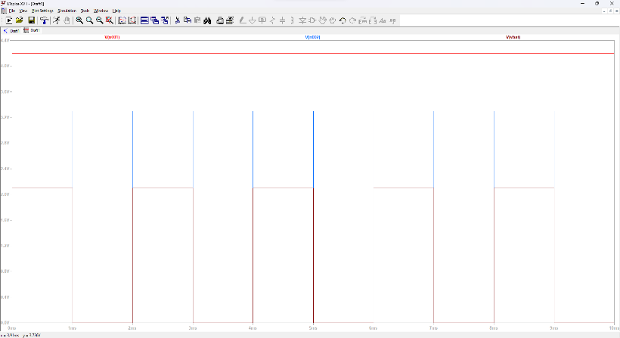
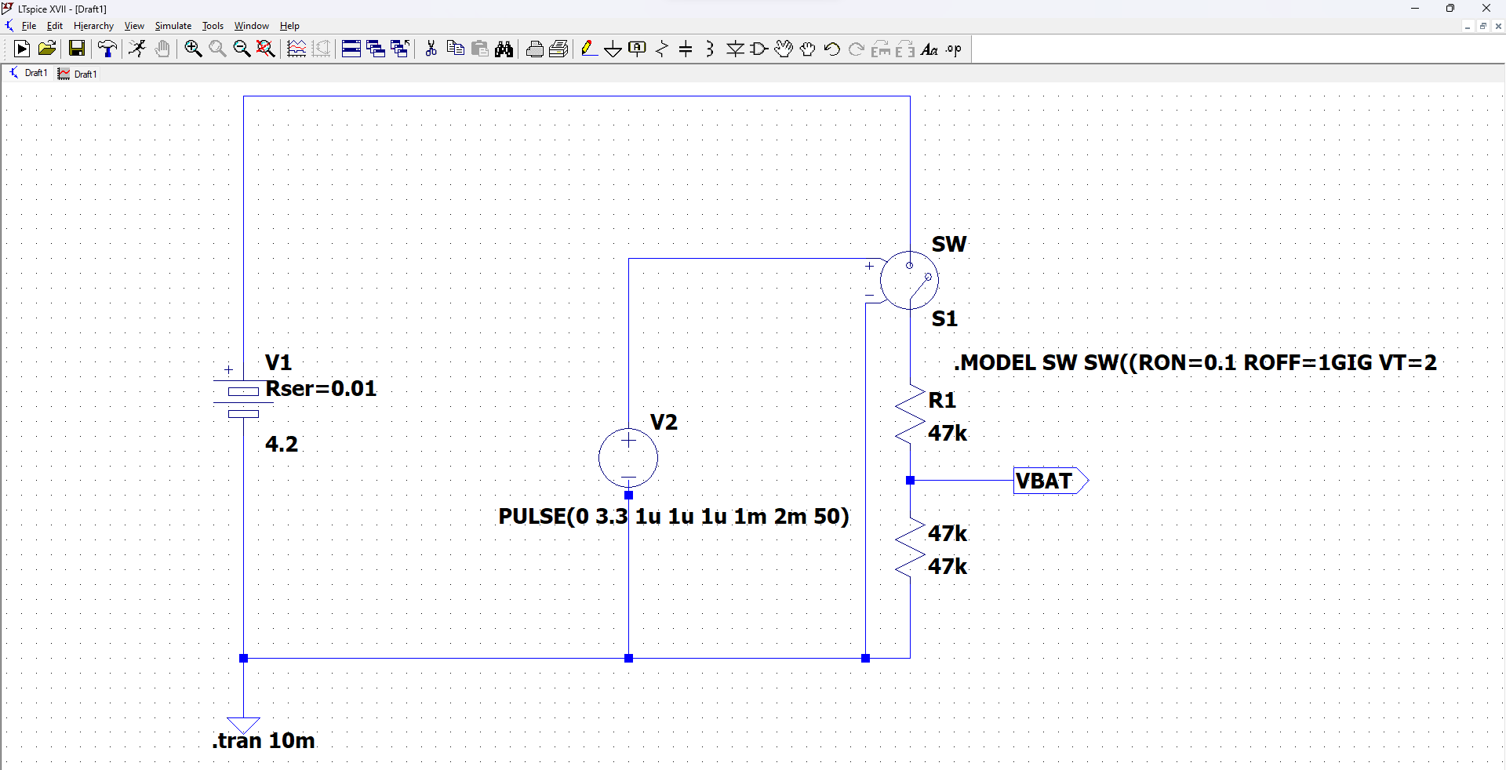
MOSFET voltage control switching
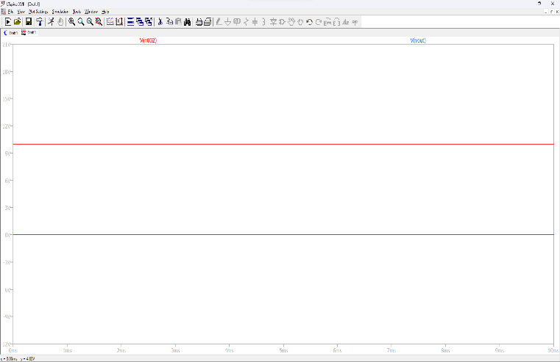
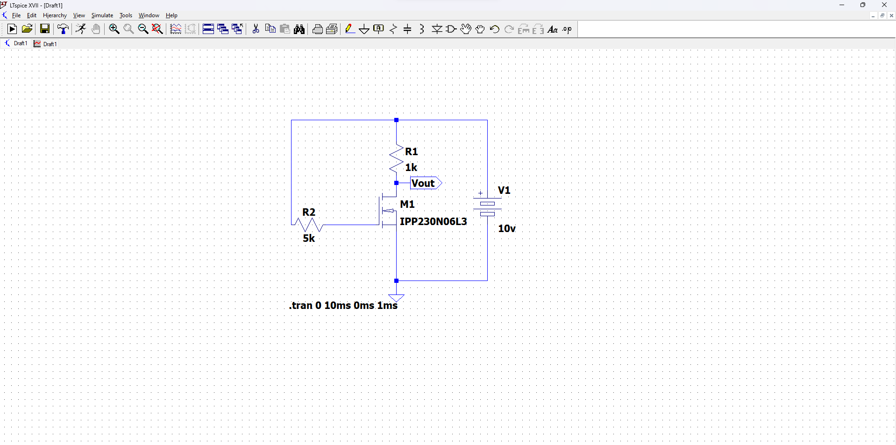

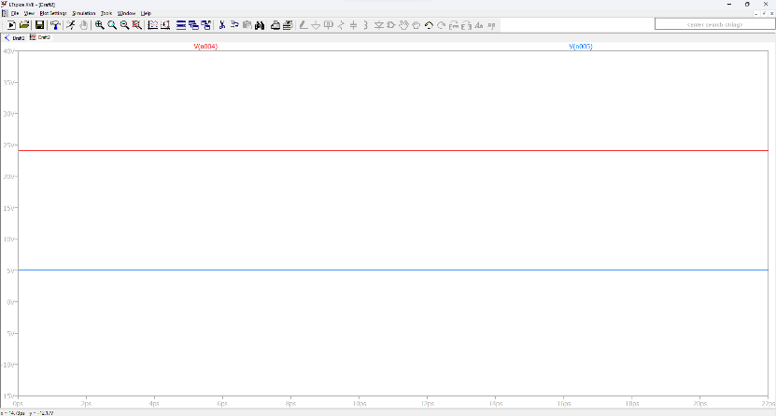
Isolated MOSFET Gate Driver using Pulse Transformer
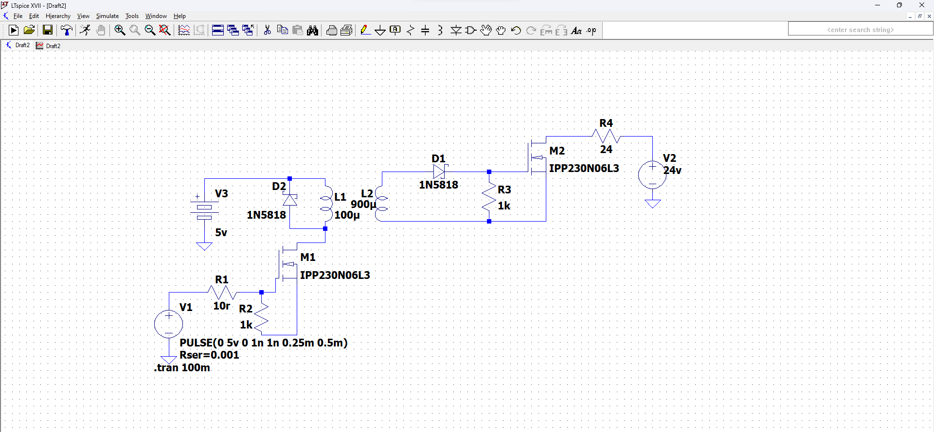

MOSFET Characteristics
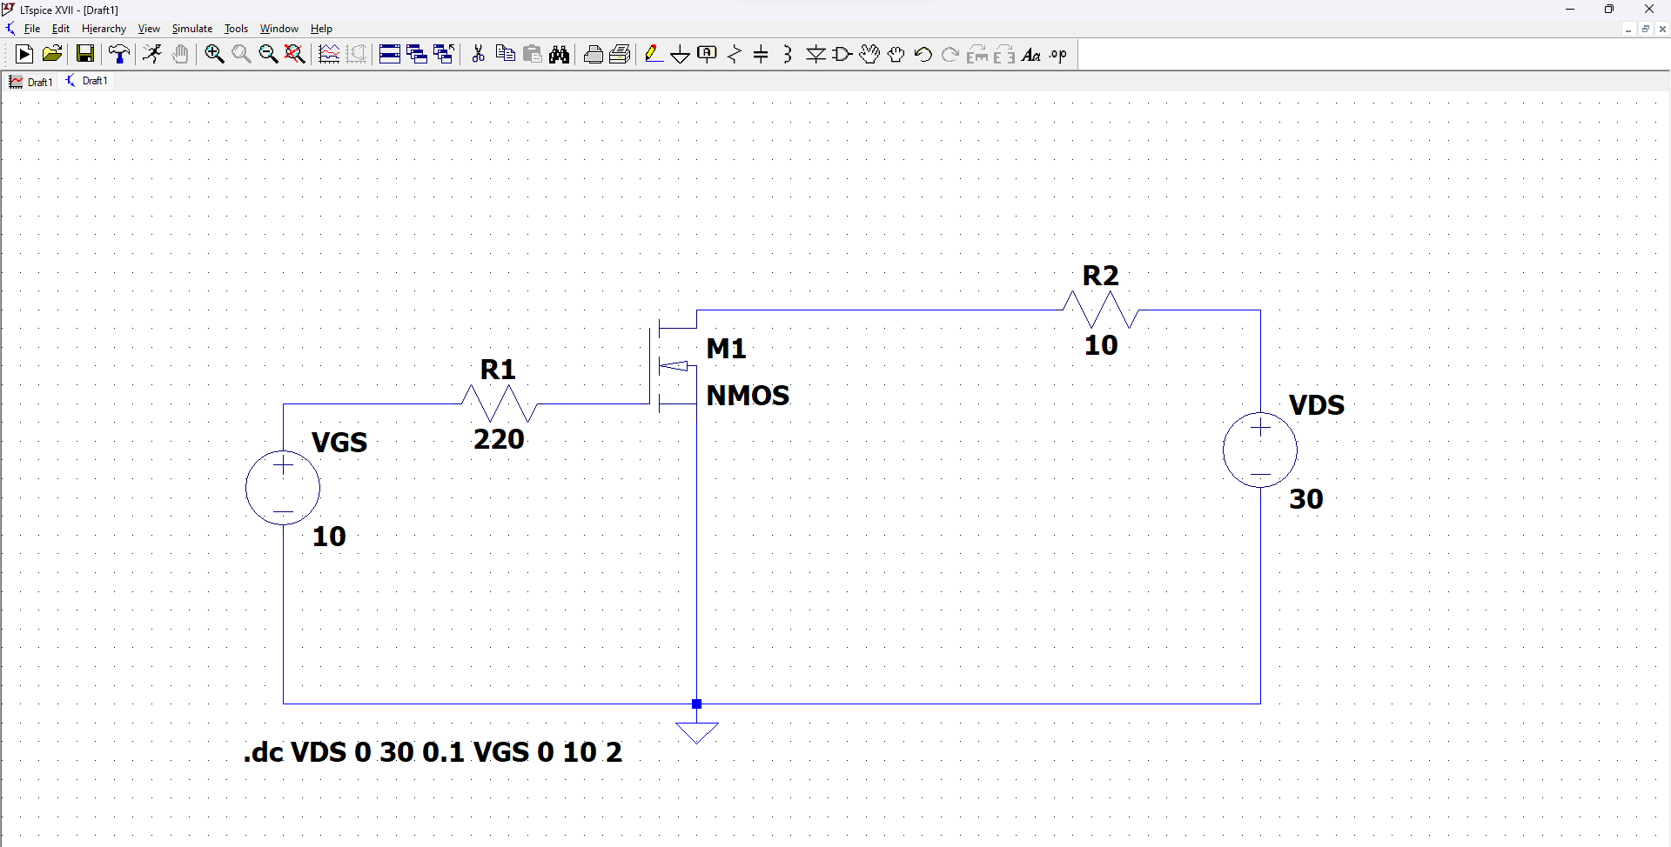

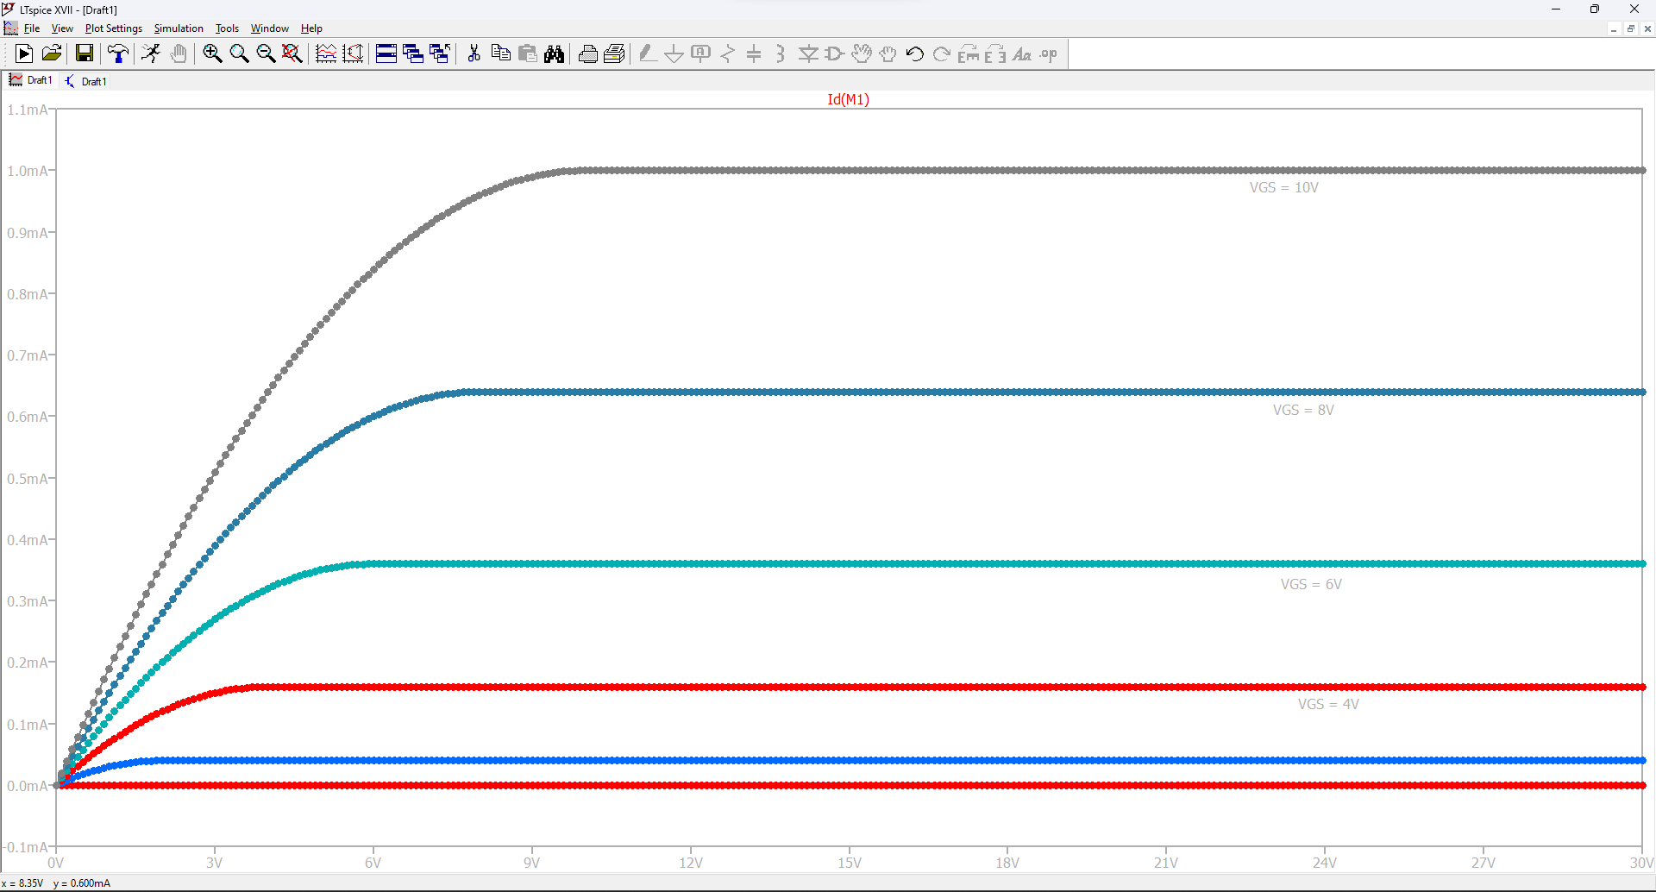

Chapter -4
Power Electronics converters
4.1. Buck Converter
A buck converter is a DC-to-DC power converter that steps down the voltage from its input (supply) to its output (load). It is a class of switched-mode power supply that uses an inductor, a controlled switch, and a diode to accomplish the voltage reduction.
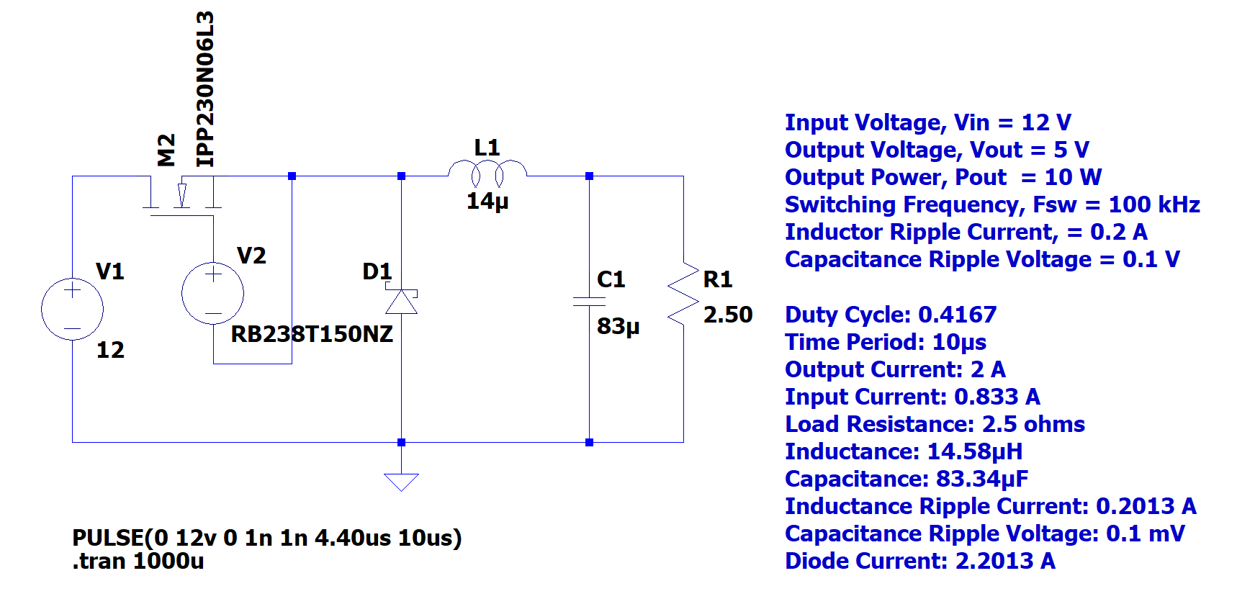
LT spice ckt design
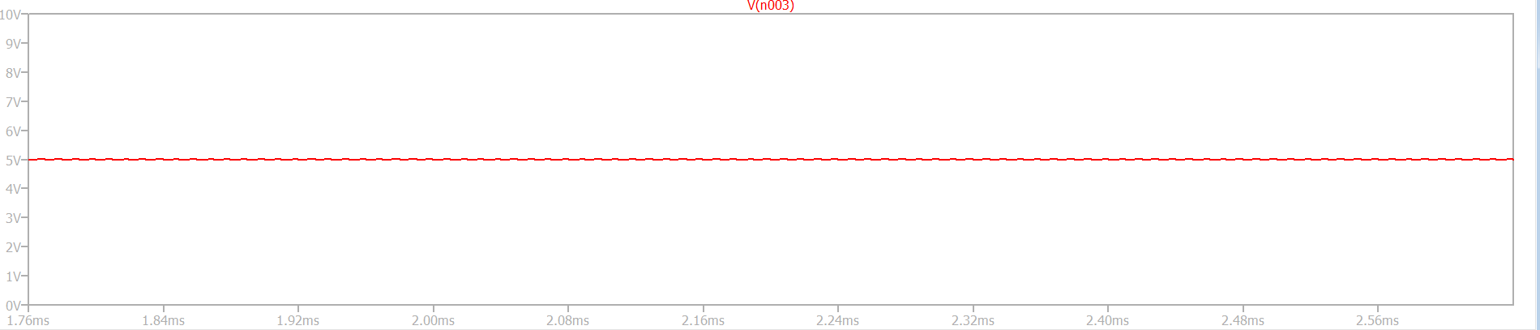
Output voltage
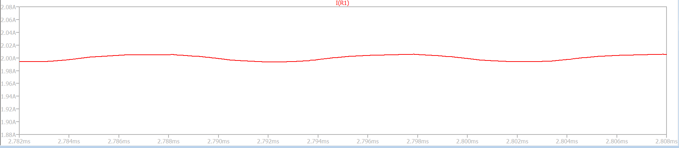
Output current

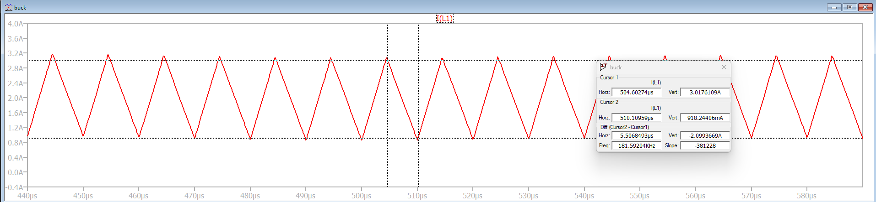
Inductor current ripple
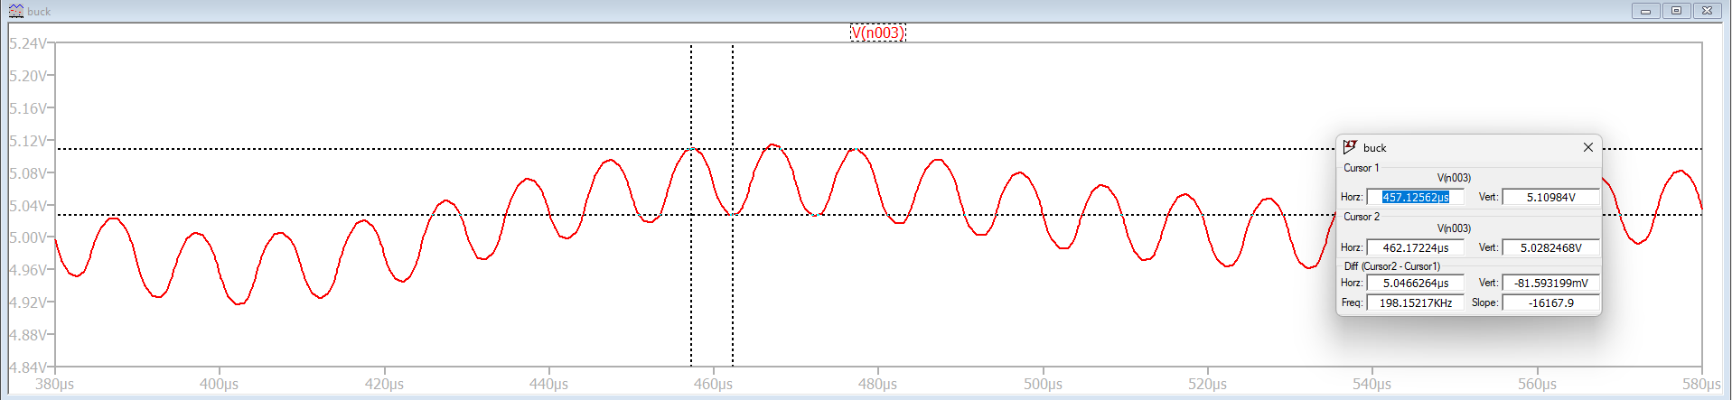
Capacitor voltage ripple
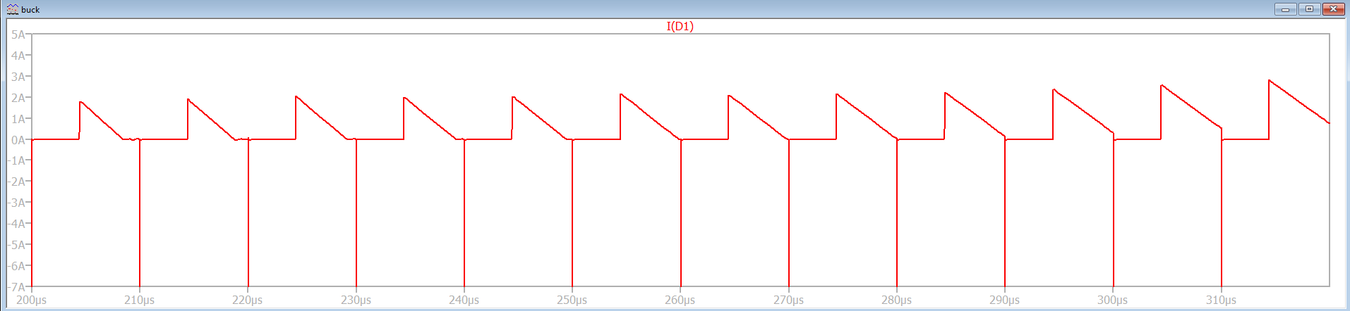
Diode Current
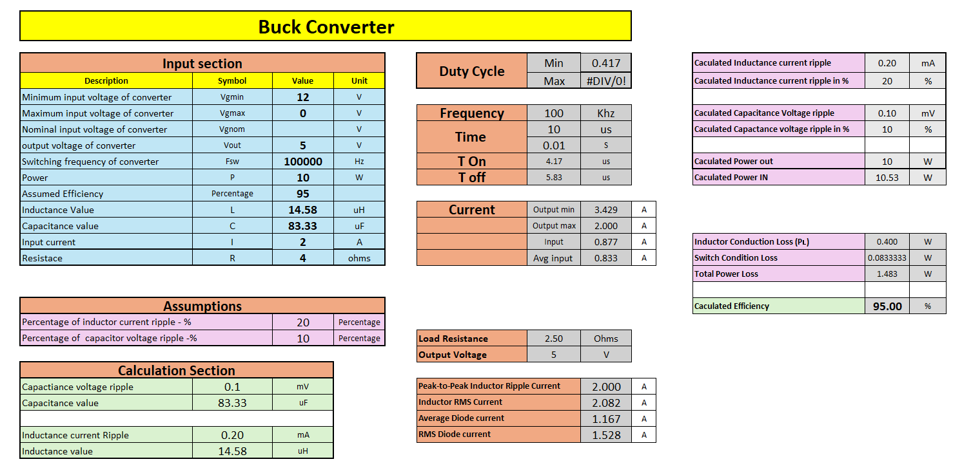
Calculation sheet

4.2. Boost Converter
A boost converter is a DC-to-DC converter that steps up the voltage from its input to its output. It is a class of switched-mode power supply that uses an inductor, a controlled switch, and a diode to accomplish the voltage increase

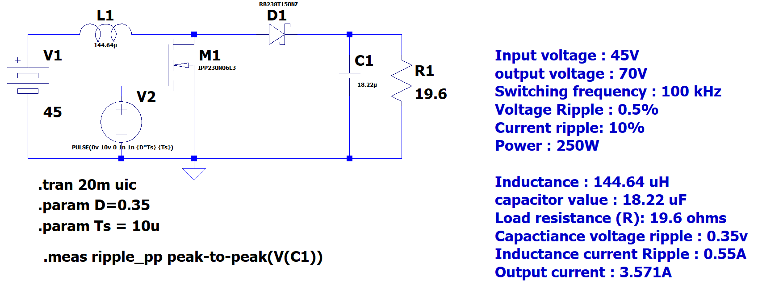
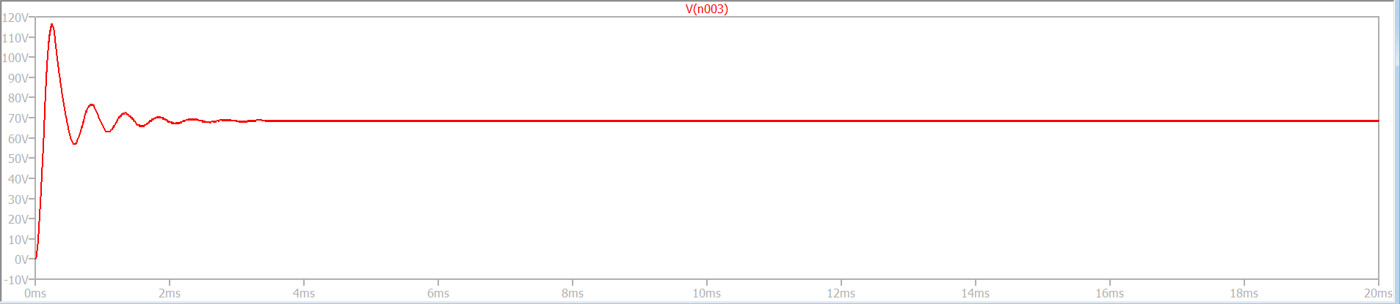
LT Spice Circuit

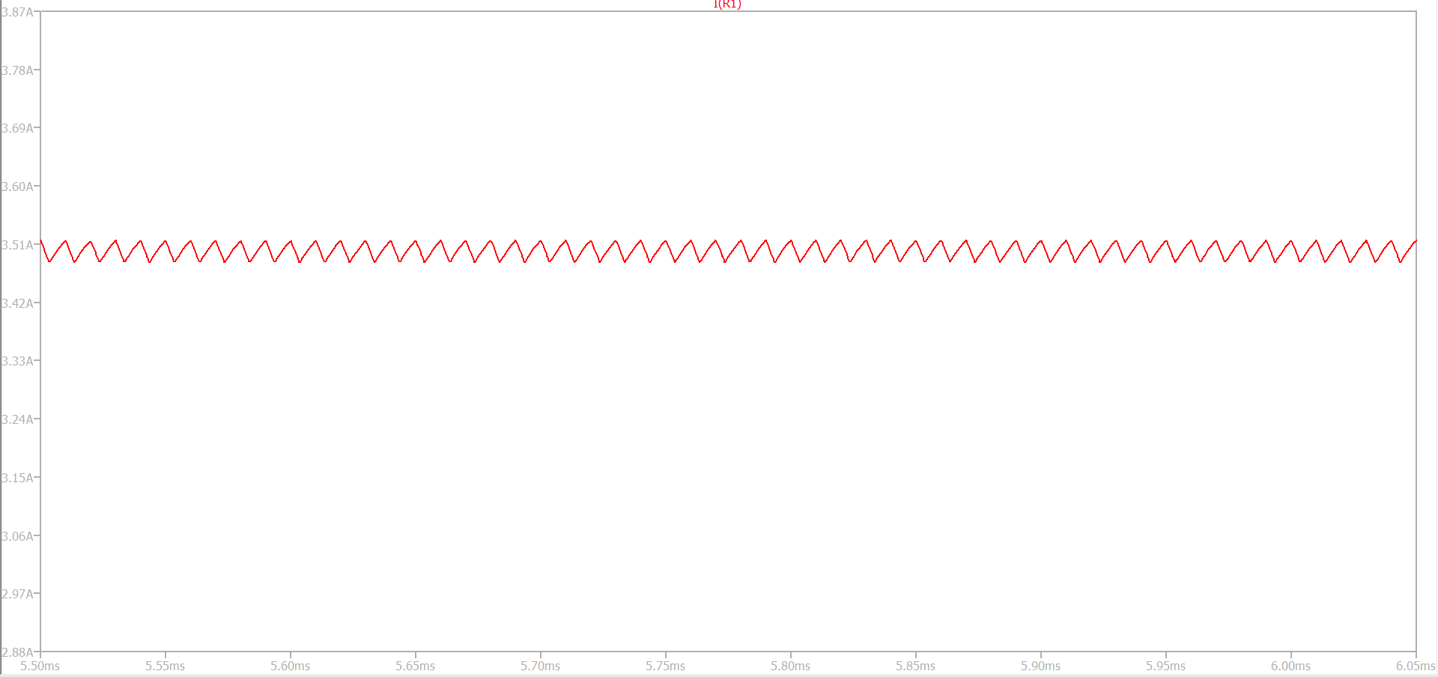
Output Voltage = 70v

Output Current = 3.57A

2.
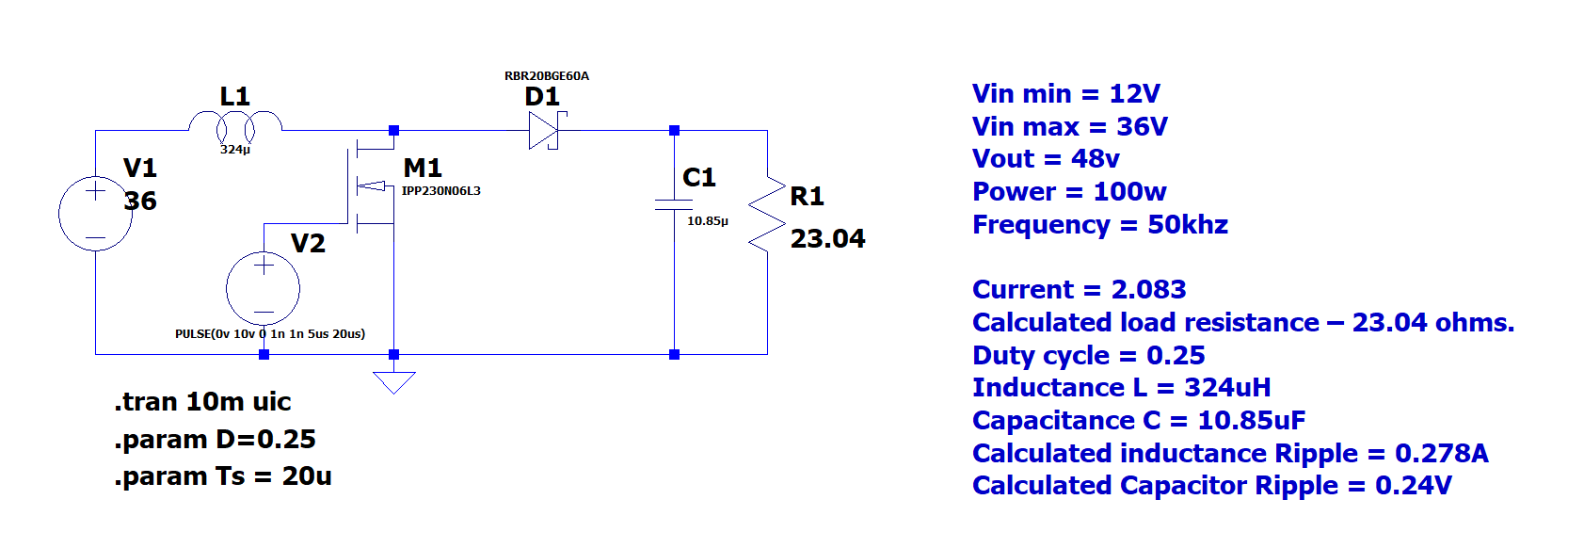
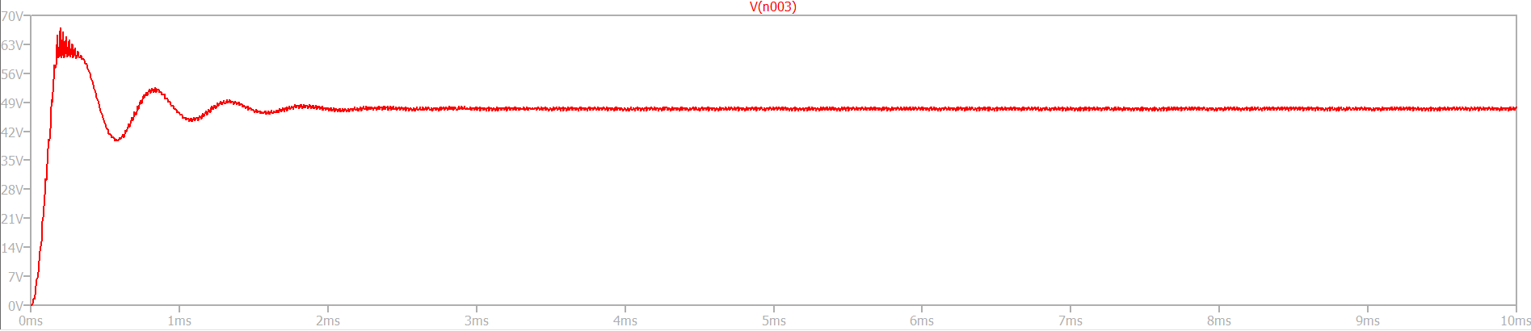
Output Voltage = 48V
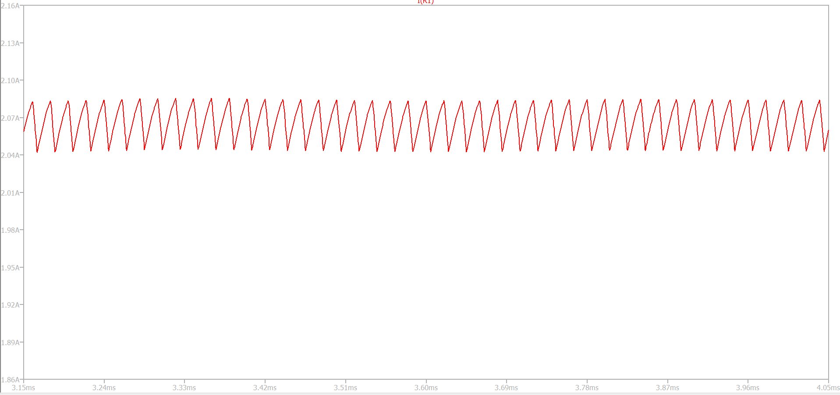
Output Current = 2.08A
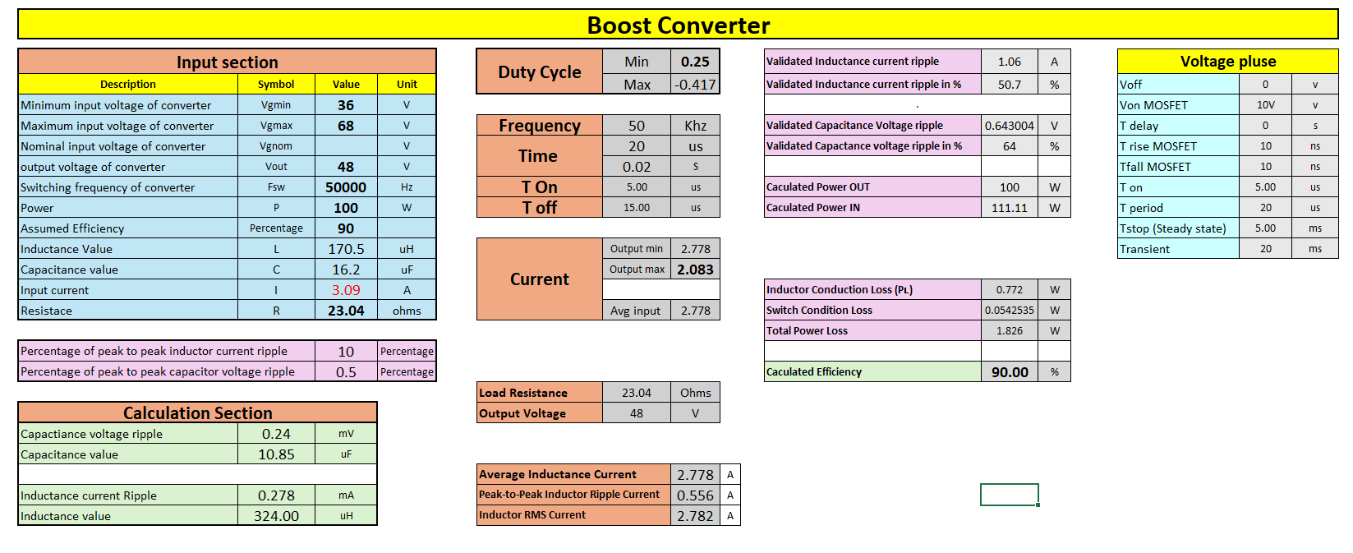Calculation Sheet
4.3. Buck-Boost Converter
A buck-boost converter is a type of DC-to-DC converter that has an output voltage magnitude that is either greater than or less than the input voltage magnitude. It is a combination of a buck converter and a boost converter.
Given data
Vin = 30 V
R = 4 Ω
V out = -20
V f = 40 kHz
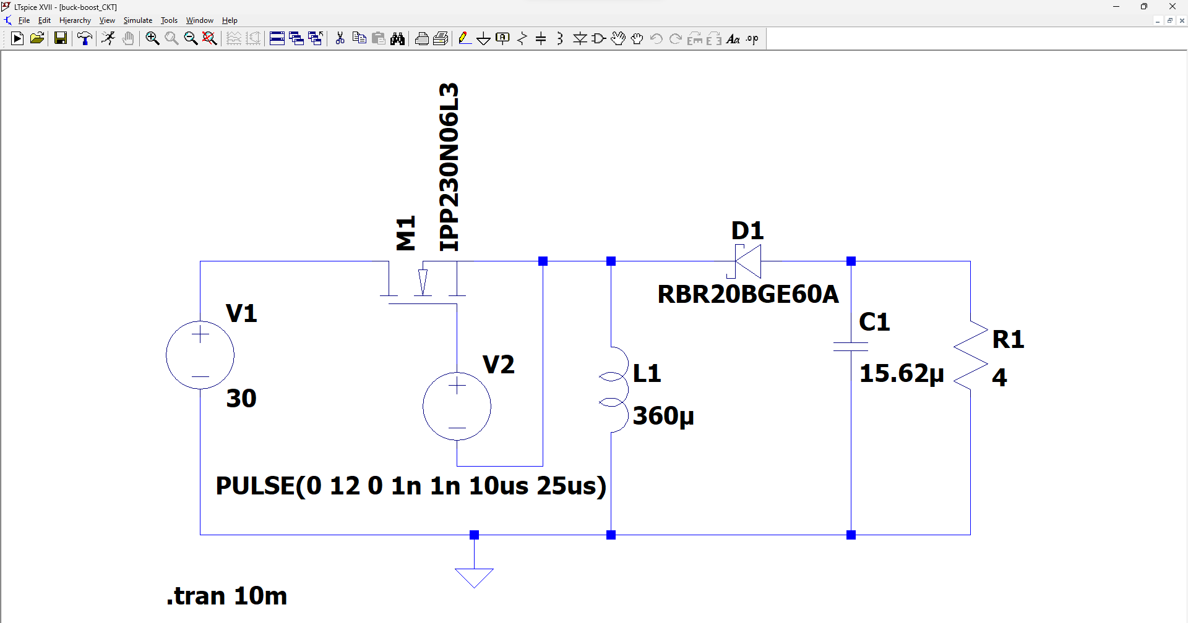
LT Spice Simulation
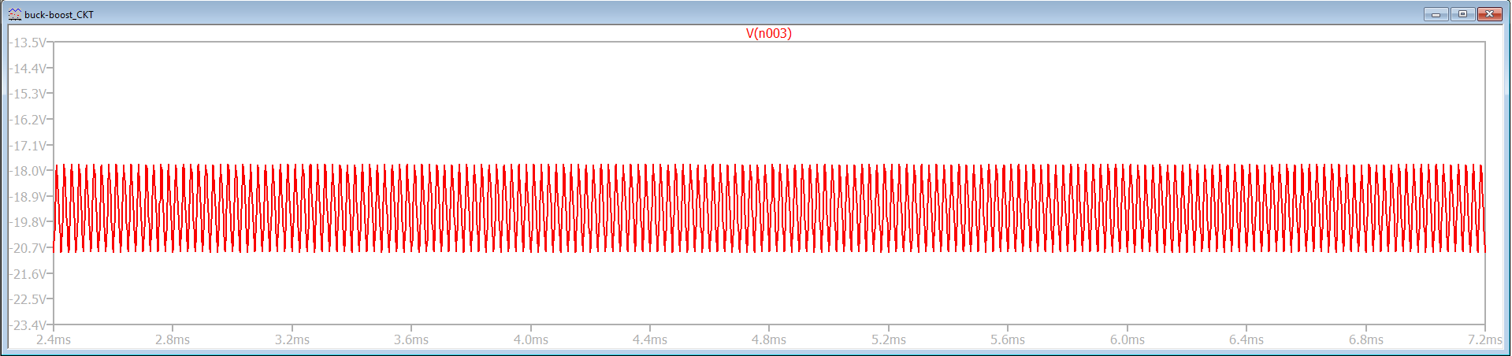
Output voltage
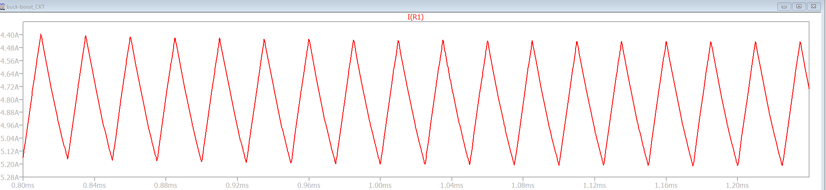
Output current

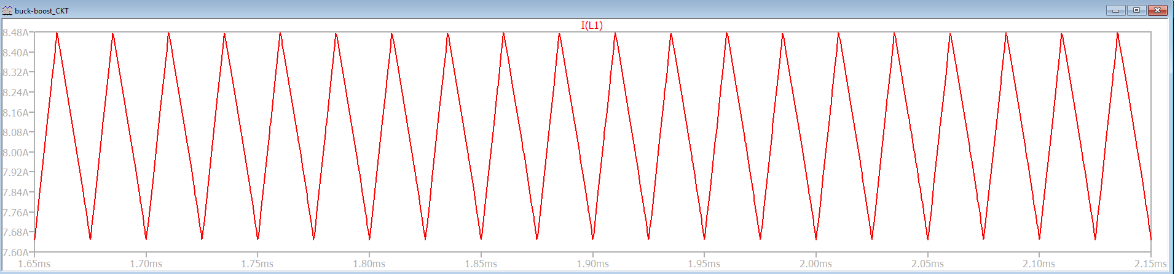
Inductance current ripple
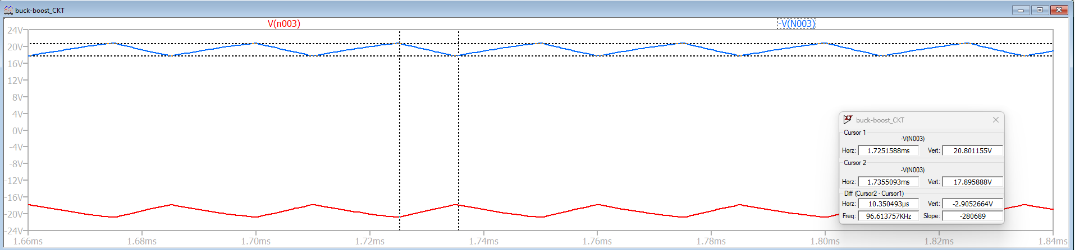
Capacitance Voltage ripple
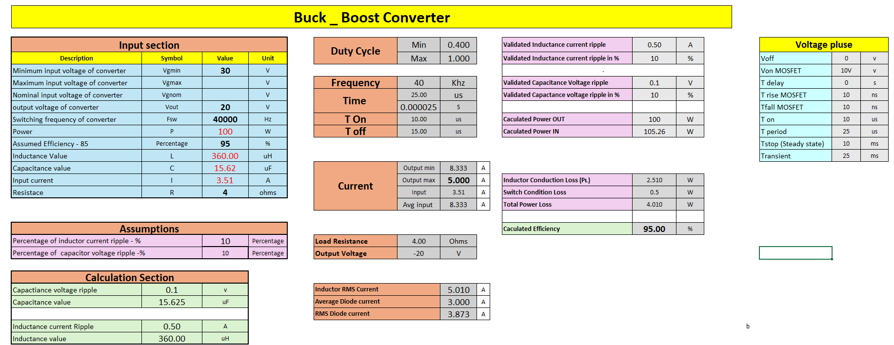

4.4. Flyback Converter
A flyback converter is a type of isolated buck-boost DC-to-DC converter. It has an advantage over the regular buck-boost converter in that it provides isolation between the input and output. The transformer provides the isolation and the ability to step-up or step-down the voltage
Figure 2 shows the schematic of the Flyback converter operated at a switching frequency of 20 kHz and duty cycle of 0.4. Assume all components are ideal. Sketch the following waveforms and indicate appropriate values [current minimum, current maximum and voltage magnitudes]. For calculations, you may assume 10% current ripple on the primary side of transformer
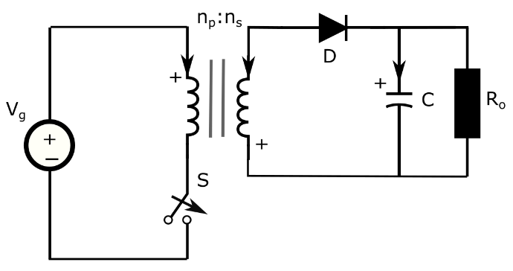
Fig. : A Flyback converter with V_{g} = 30 V, n_{p}:n_{s} = 1:0.5, R_{o} = 6 Ohms [plus signs at the winding are similar to your dot notations].
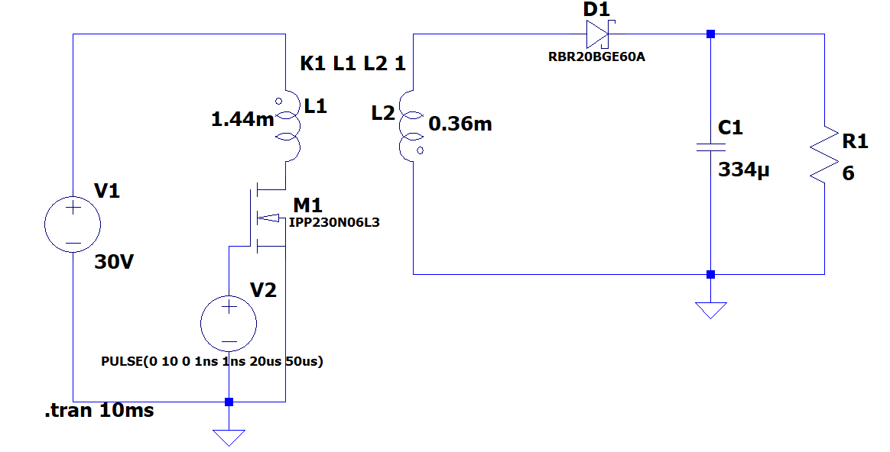
LT spice Simulation
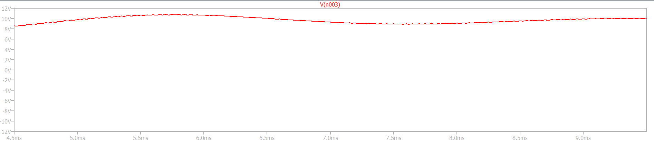
Output voltage = 8.5v
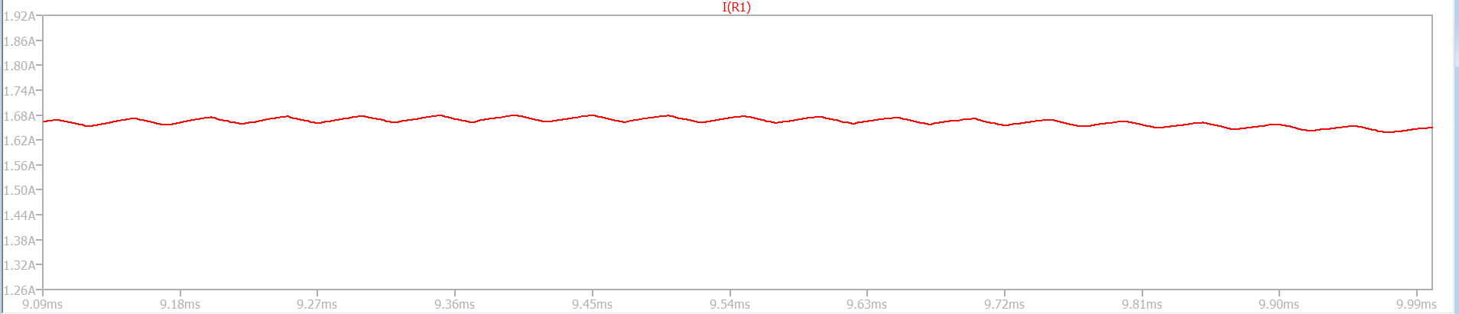
Output current = 1.65A

- Primary voltage waveforms
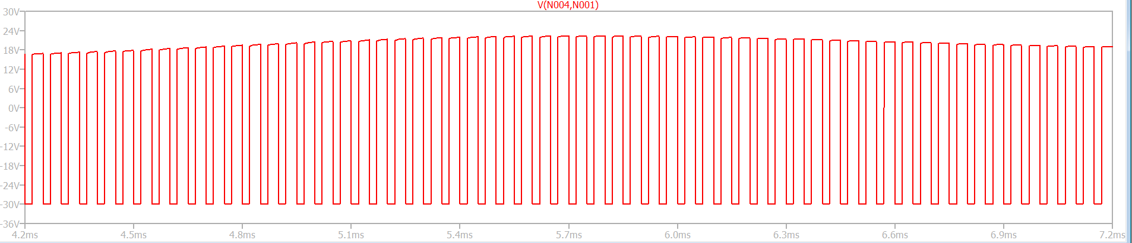

secondary voltage waveforms
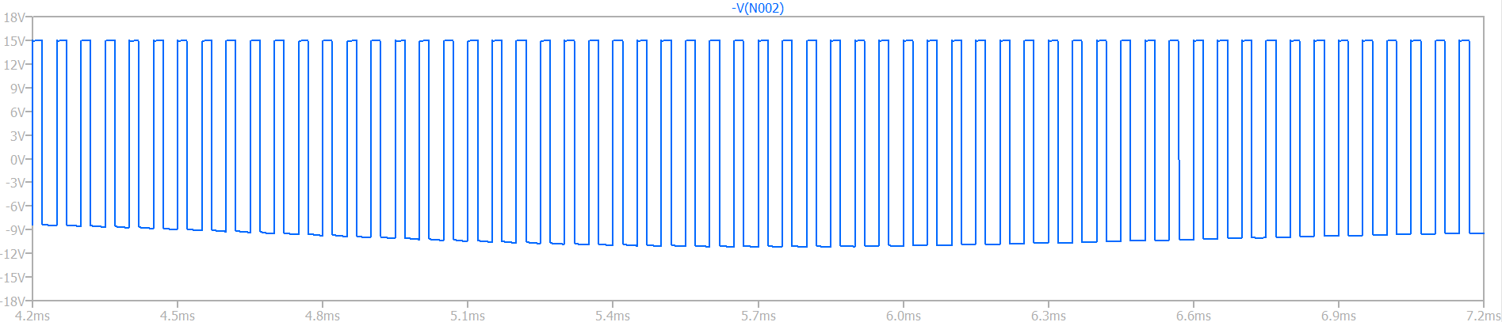
Primary current waveforms
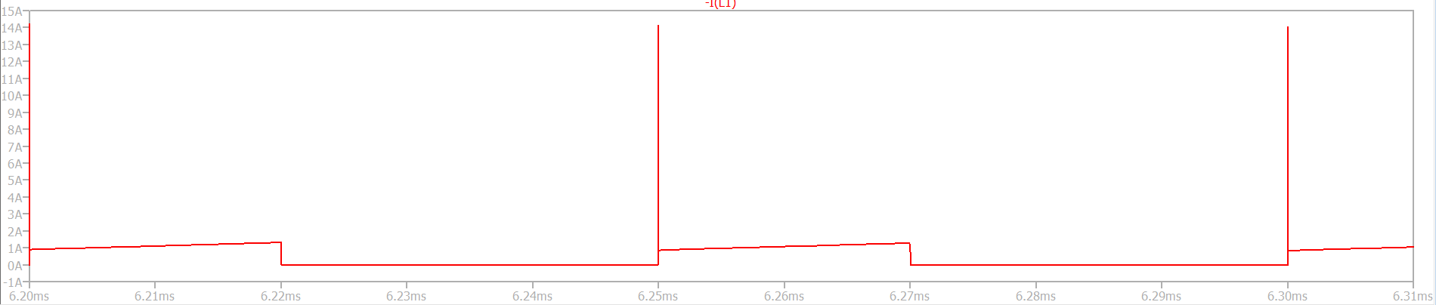
secondary current waveforms
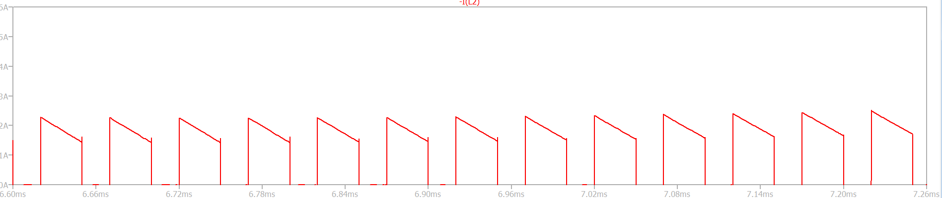
Capacitor current
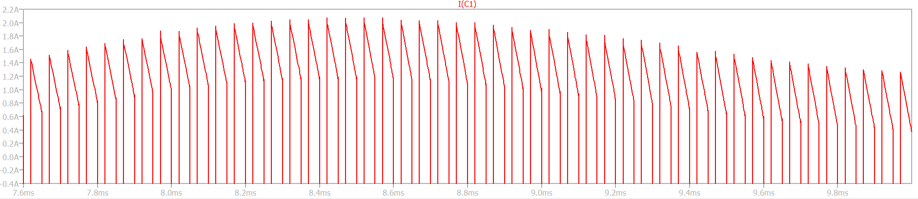
Capacitor voltage
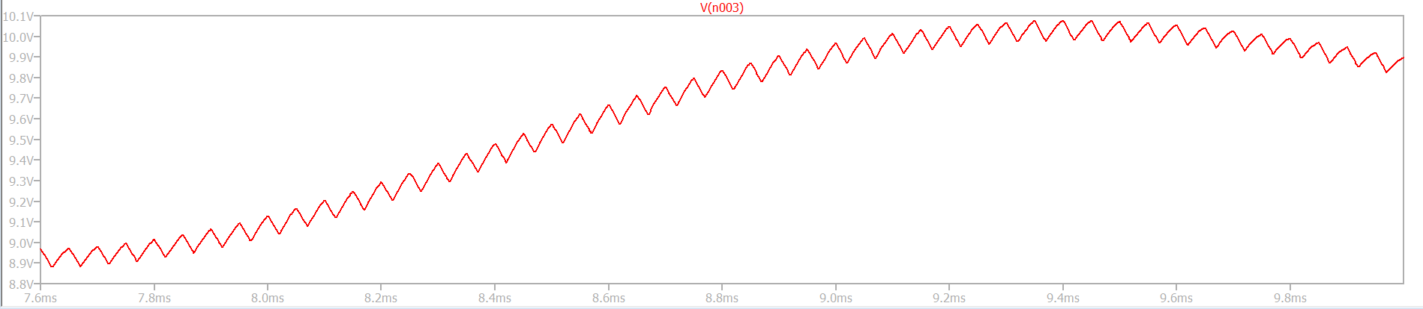
Voltage waveforms of switch and diode
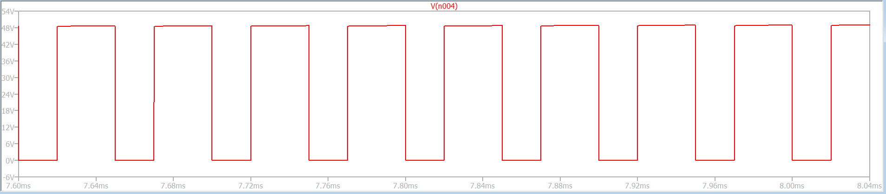
MOSFET [IPP230N06L3] Voltage waveforms
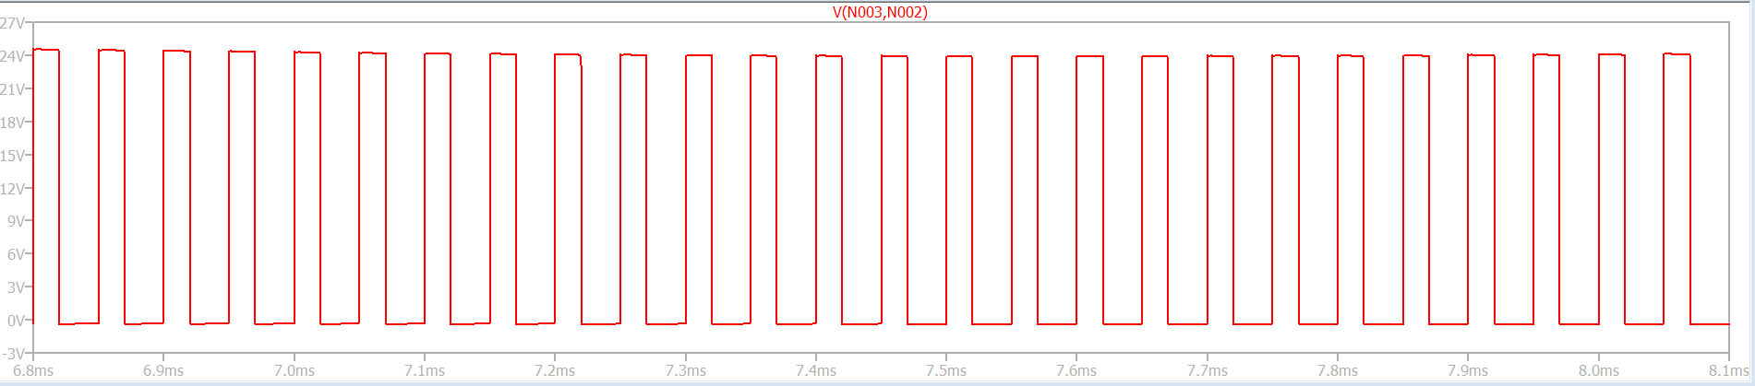
Diode [RBR20BGE60A] Voltage waveforms
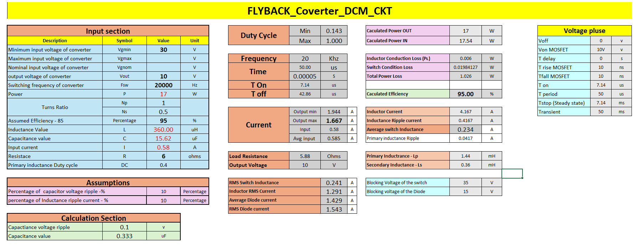

4.5. Forward Converter
A forward converter is a type of DC-to-DC converter that transfers energy from the primary to the secondary winding of a transformer while the switching element is in the "on" state. It is commonly used to either increase or decrease DC voltages or convert a single voltage to multiple DC output voltages.
Figure shows the schematic of the Forward converter operated at a switching frequency of 20 kHz and duty cycle of 0.4. Assume all components are ideal. Sketch the following waveforms and indicate appropriate values [current minimum, current maximum and voltage magnitudes].
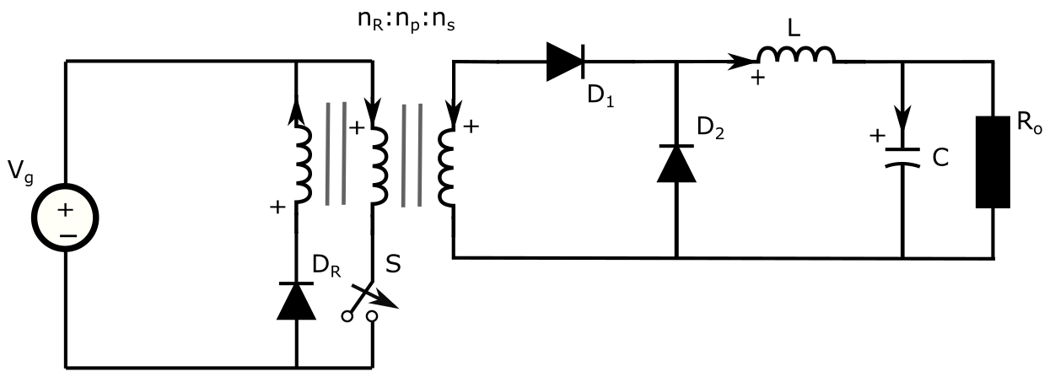
Switching Frequency : 20 kHz
Duty Cycle (D): 0.4
Input Voltage : 30 V
Transformer Turns Ratio : 1:1:0.5
Load Resistance : 6 Ω
Inductor : 1 mH
Capacitor : 20 μF
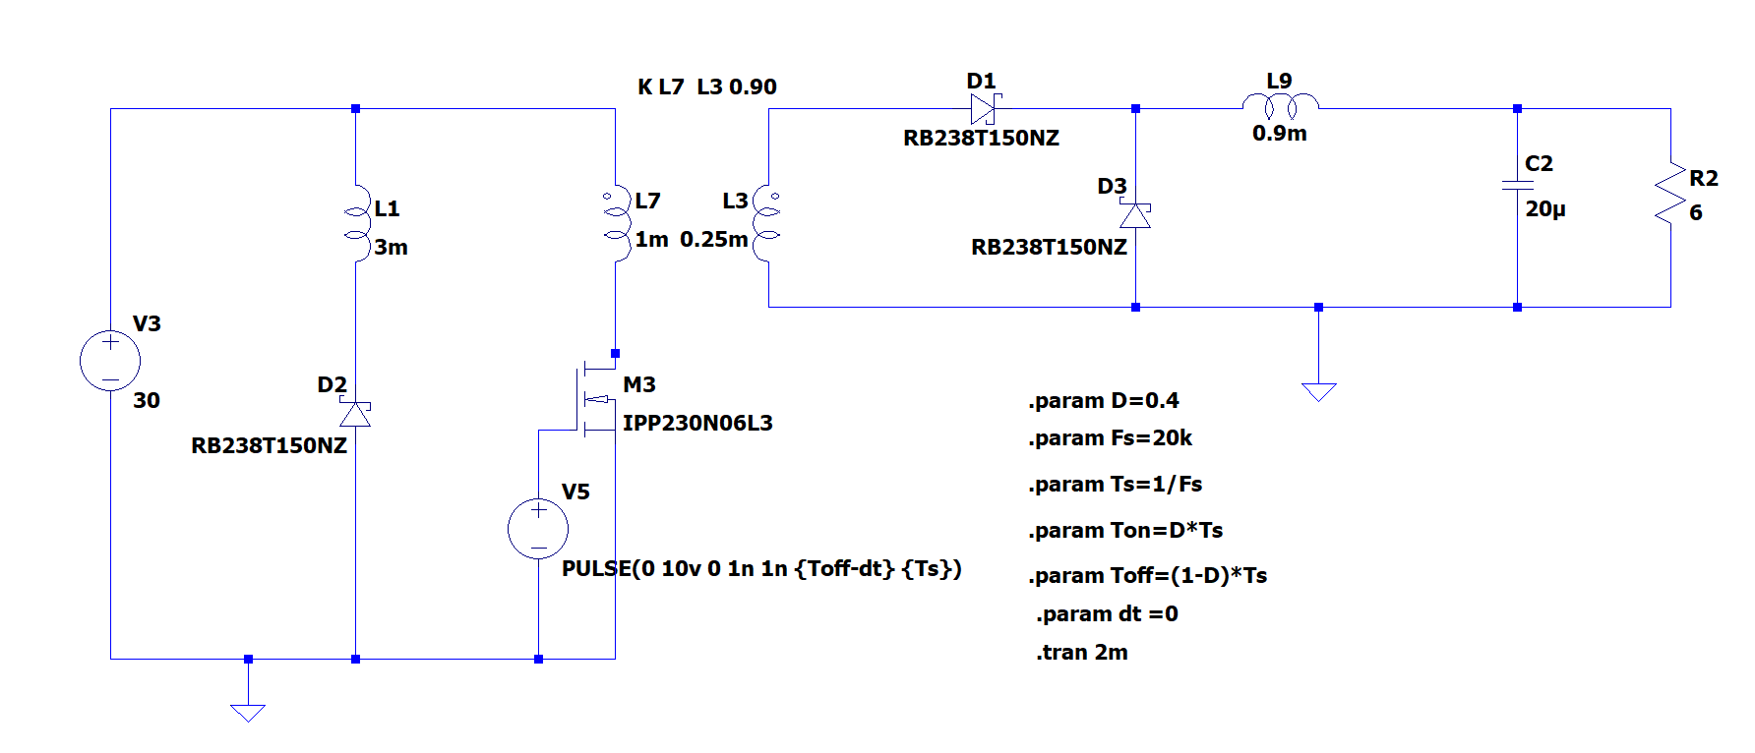
LT Spice Circuit
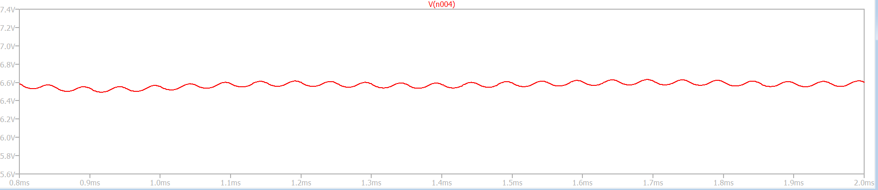
Output Voltage

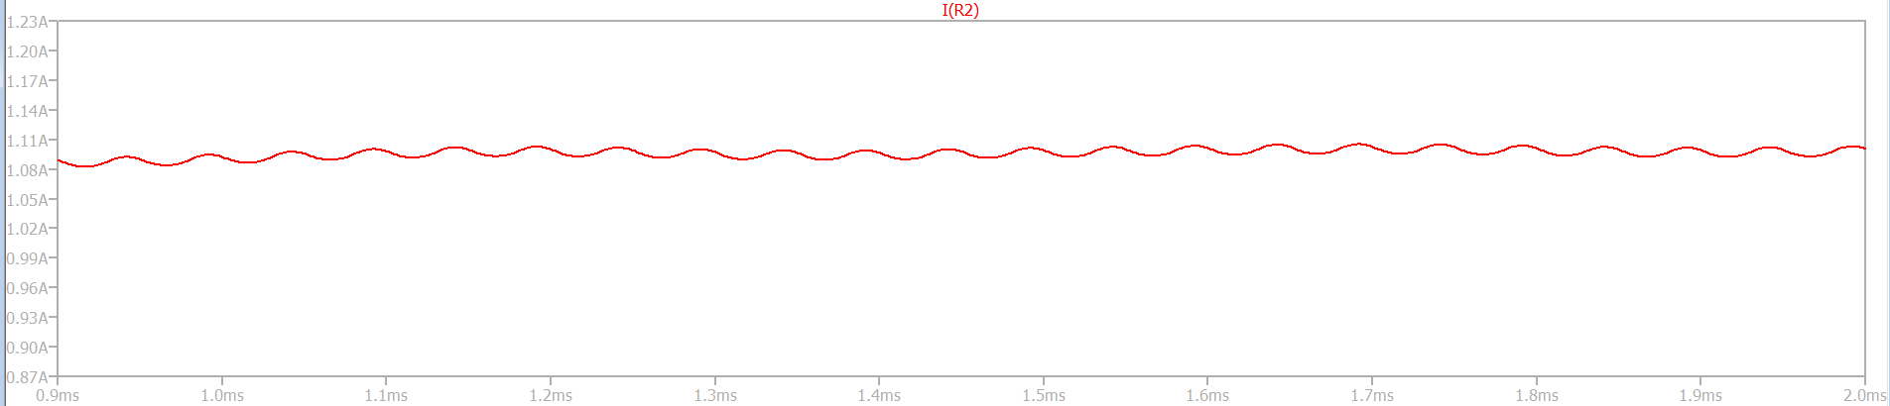
Output current

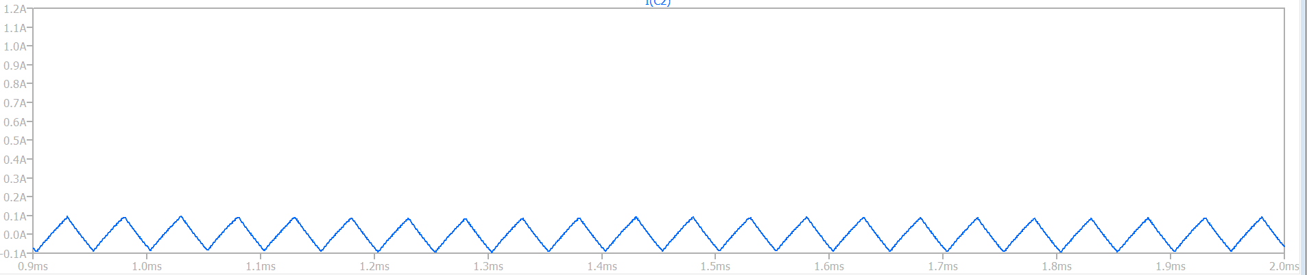
Capacitor Current
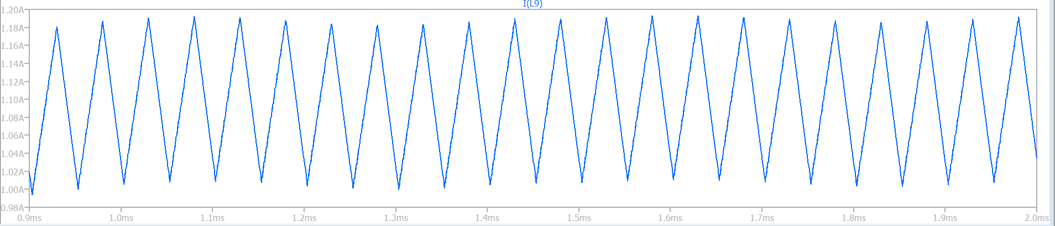
Inductance Current
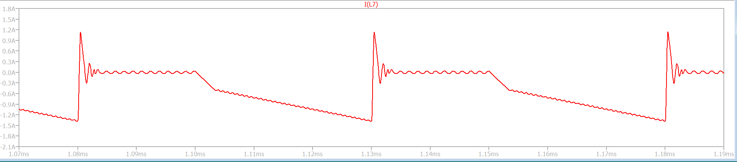
Primary Inductance Current
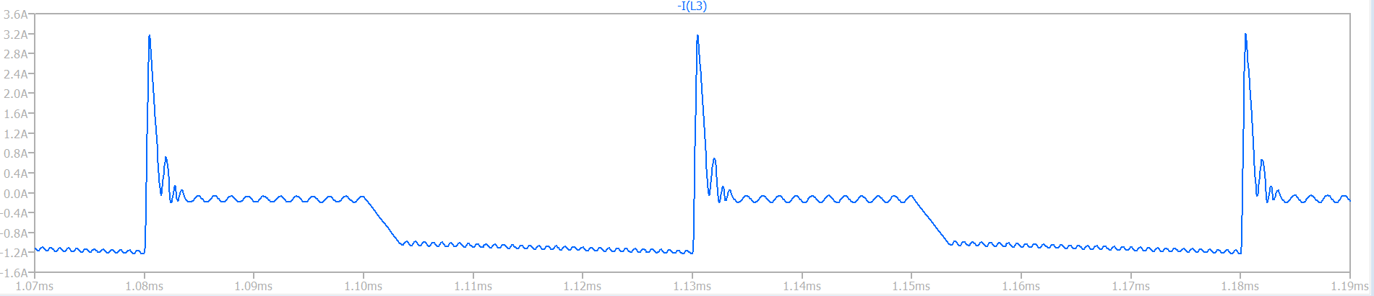
Secondary inductance current
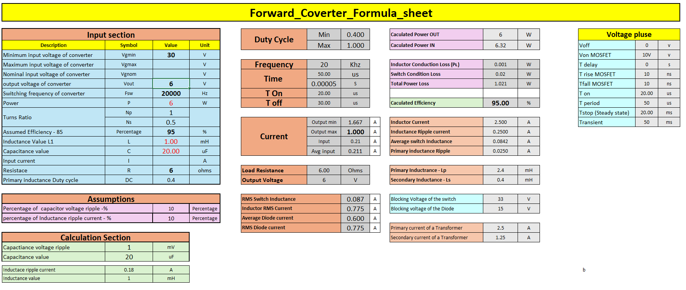

4.6 push-pull.
A push-pull converter is a type of isolated DC-to-DC converter that uses two transistors connected to a centre-tapped transformer. It is a variation of the buck-boost converter. The push-pull converter can provide a step-up or step-down output voltage.
Vin – 12v
Vout – 24v
Output power = 50w
Frequency = 100khz
Duty cycle = 0.4
Assume - Peak current = 5A
Calculate – Transformer turns ratio, output current, output voltage, primary and Secondary inductance values, output capacitor filter, output filter inductance, Load resistance?
Calculated
Transformer turns ratio – 4
output current – 2.08A
output voltage – 24v
primary inductance value – 12uH
Secondary inductance value – 192uH
Output capacitor filter – 43.33uf
Output filter inductance – 45uH
Load resistance – 11.52 ohms

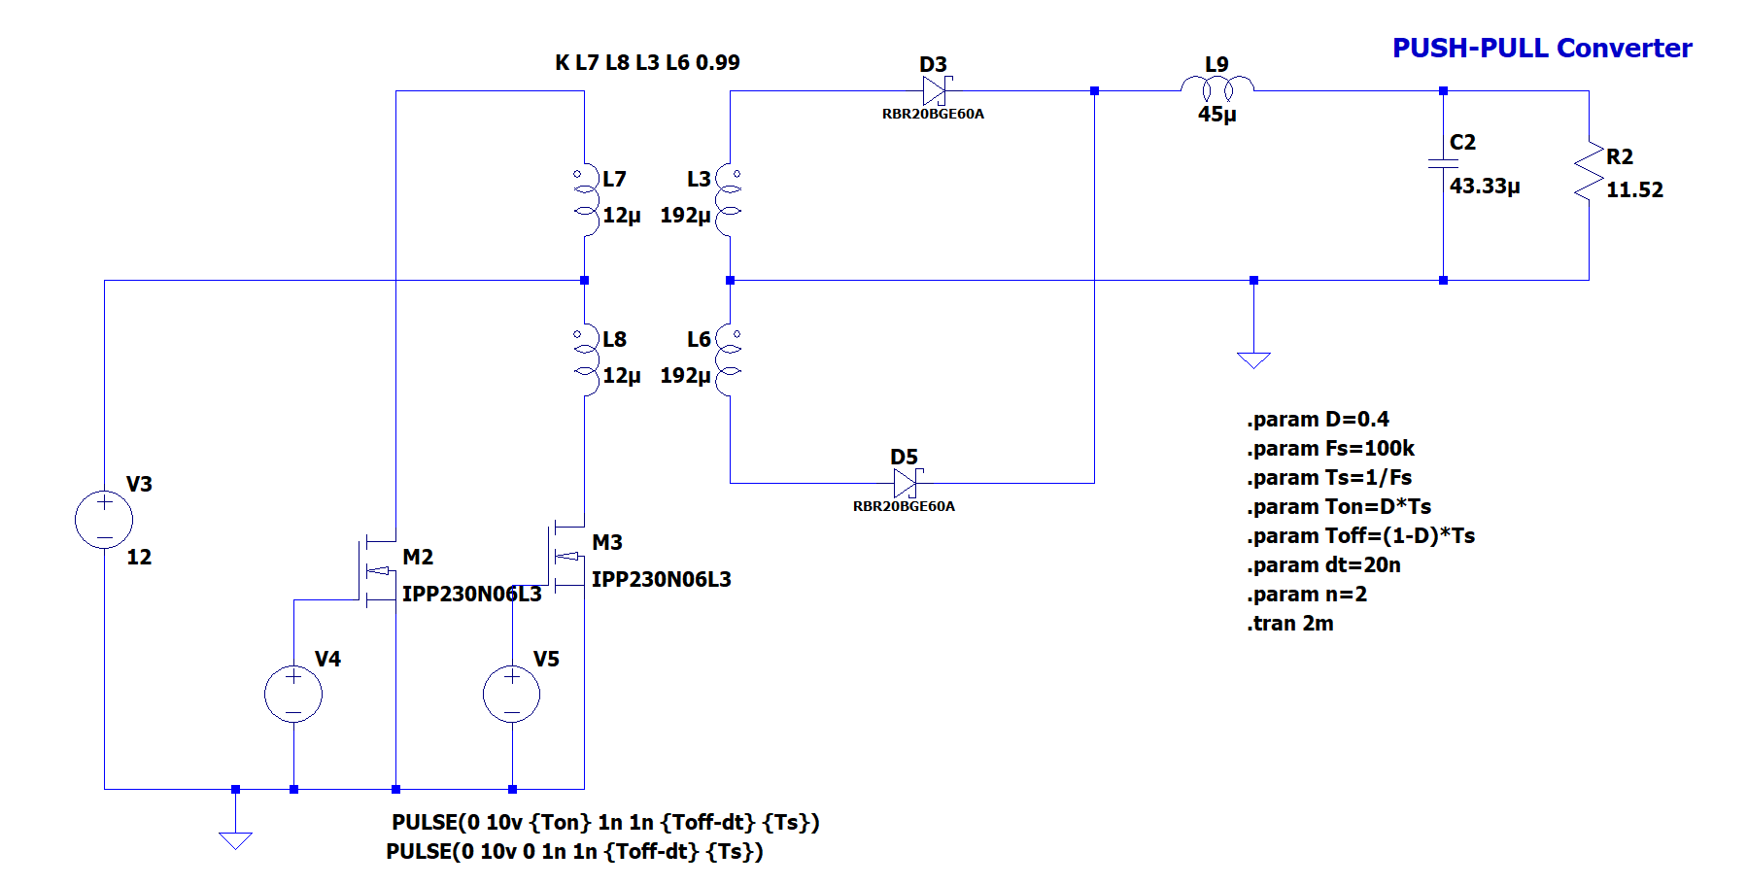
LT spice Simulation
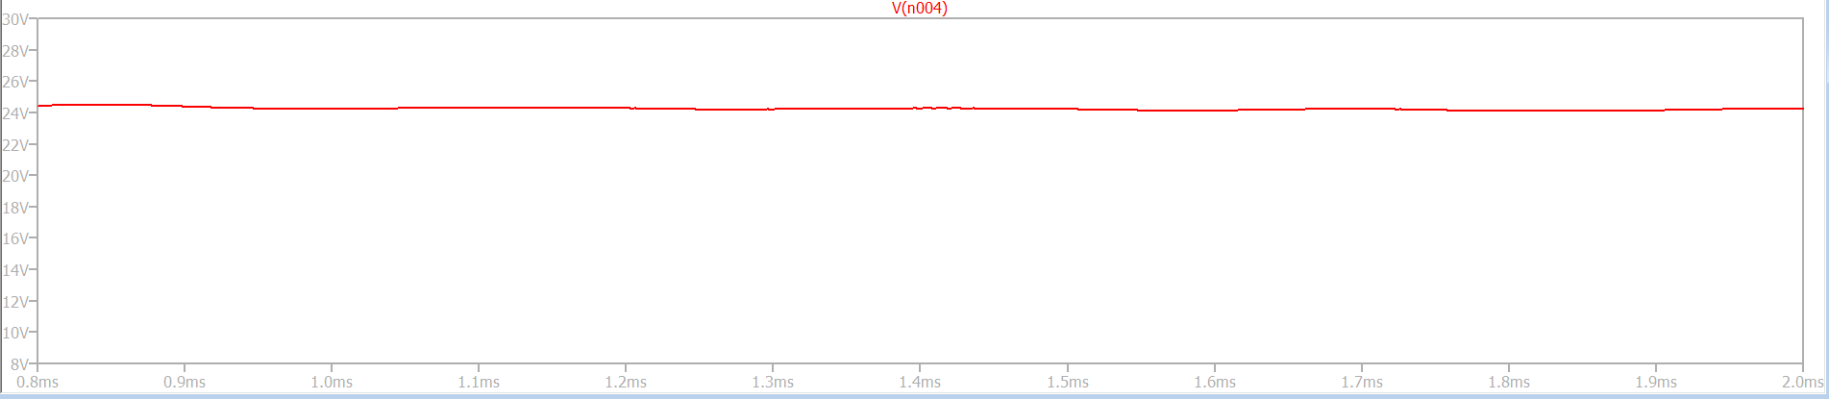
Output voltage
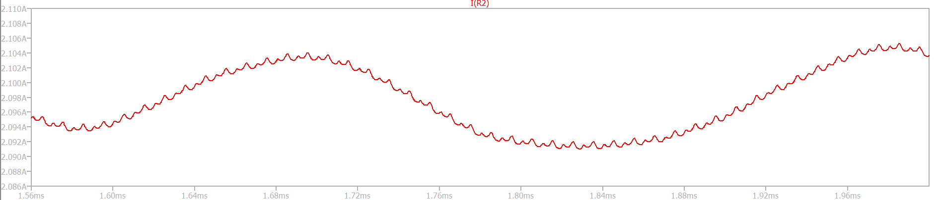
Output current
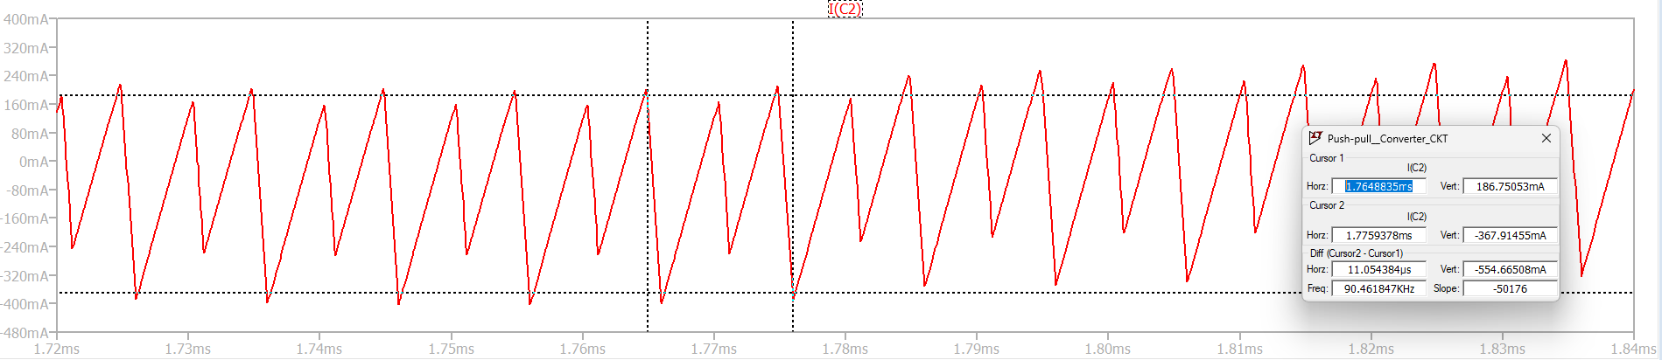
Capacitor current
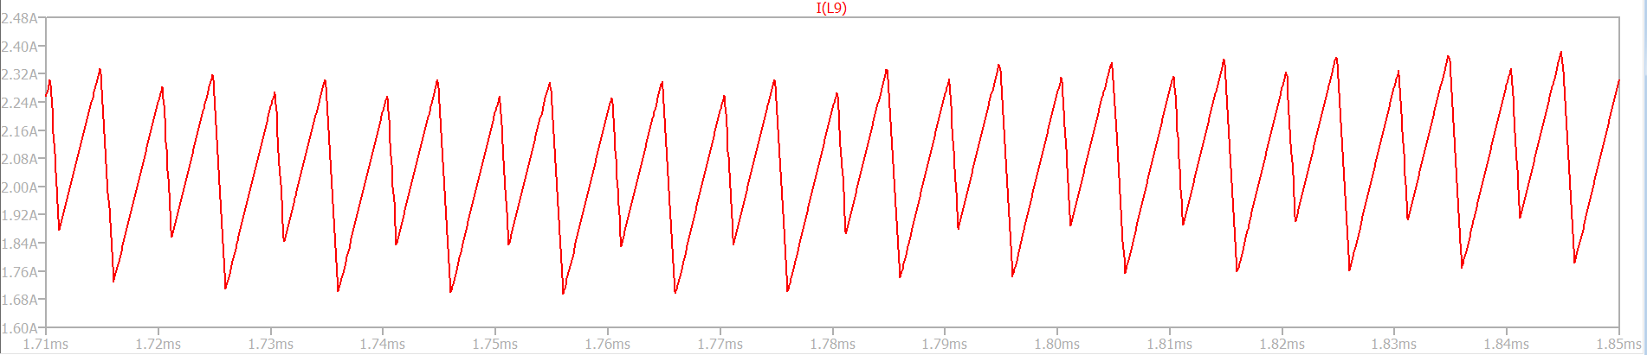
Inductance current

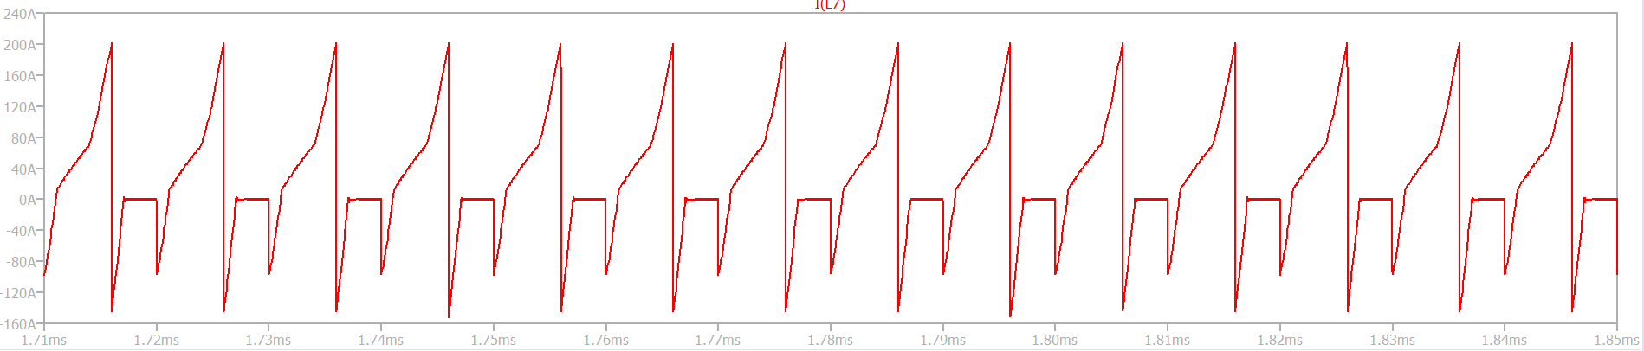
Primary Inductance Current
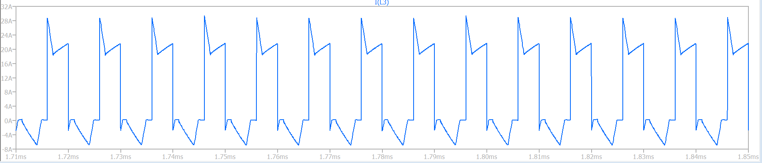
Secondary Inductance current
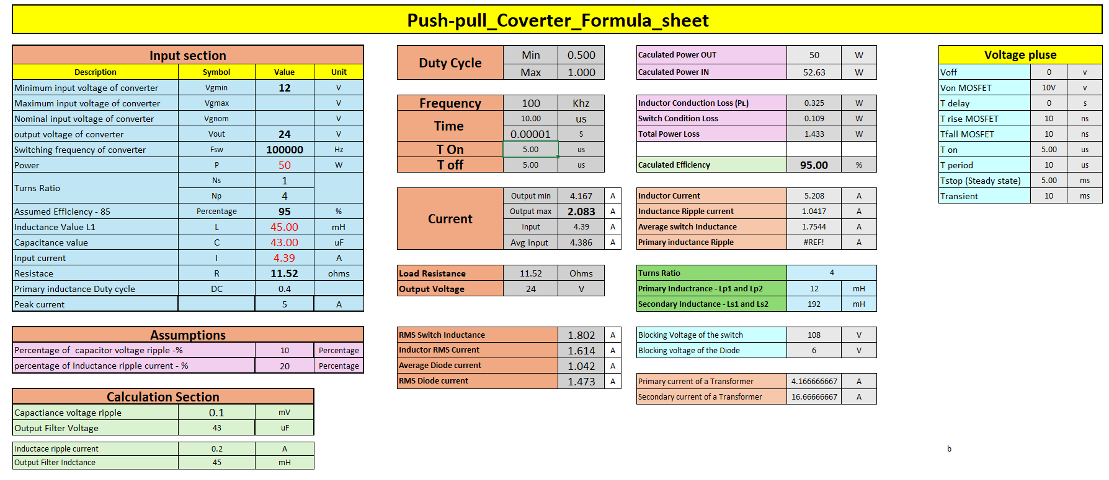
Calculation sheet

Chapter -5
Gate Drivers and GaN MOSFETs

5.1. NCP51820 Gate Driver (ON Semiconductor)
NCP51820: A High-Speed Half-Bridge Driver for GaN Power Switches
The NCP51820 is a powerful and versatile gate driver designed to meet the stringent requirements of driving enhancement mode (e-mode), high electron mobility transistor (HEMT) and gate injection transistor (GIT) gallium nitride (GaN) power switches. This high-speed, half-bridge driver offers a range of advanced features that make it well-suited for a variety of power electronics applications.
Key Features
High-Speed Operation: The NCP51820 is optimized for driving GaN power switches, providing fast rise and fall times of just 1 ns. This enables efficient high frequency switching in power conversion topologies.
Wide Common Mode Voltage Range: The advanced level shift technology in the NCP51820 provides a -3.5 V to +650 V common mode voltage range for the high-side drive, and a -3.5 V to +3.5 V range for the low-side drive. This flexibility allows the driver to be used in a wide range of applications.
Stable dV/dt Operation: The NCP51820 is rated for dV/dt up to 200 V/ns, ensuring stable and reliable operation even in high-speed switching environments.
Dedicated Gate Protection: The driver employs independent voltage regulators for both the high-side and low-side drive stages. This maintains the gate-source drive signal amplitude, protecting the GaN power transistors from excessive voltage stress.
Comprehensive Protection Features: The NCP51820 includes under-voltage lockout (UVLO) monitoring for the VDD bias voltage and VDDH/VDDL driver bias, as well as thermal shutdown based on the die junction temperature.
Programmable Dead-Time Control: The dead-time between the high-side and low-side drive signals can be configured to prevent cross-conduction, ensuring safe and efficient operation.
High Drive Capability: The NCP51820 provides a source capability of 1 A and a sink capability of 2 A, enabling it to drive a wide range of GaN power switches.
Input Compatibility: The driver features dual TTL compatible Schmitt trigger inputs, simplifying integration with microcontrollers and digital signal processors.
Applications
The NCP51820 is well-suited for a variety of power electronics applications, particularly those involving soft-switching topologies:
Soft-switching full or half-bridge converters
LLC resonant converters
Active clamp flyback or forward converters
Synchronous rectifier topologies
5.2. GaN3R2-100CBE MOSFET (Nexperia)
The GAN3R2-100CBE is a 100 V, 3.2 mΩ Gallium Nitride (GaN) FET designed for high efficiency and high power density applications. It features low on-state resistance, high frequency switching capabilities, and is housed in a compact Wafer Level Chip-Scale Package (WLCSP).
Key Features:
Enhancement Mode (Normally-Off) Power Switch: Provides high efficiency and high power density.
High Frequency Switching: Capable of ultra-high frequency switching.
Low On-State Resistance (RDS(on)): 3.2 mΩ maximum.
Low Gate and Output Charge: Reduces switching losses.
No Body Diode: Eliminates reverse recovery losses.
ESD Protection: Enhanced reliability.
RoHS, Pb-Free, REACH-Compliant: Environmentally friendly.
Applications:
Power Conversion: High power density and high efficiency applications.
AC-to-DC Converters: Particularly useful for the secondary stage.
DC-to-DC Converters: Ideal for high frequency converters in 48 V systems.
Fast Battery Charging: Suitable for mobile phones, laptops, tablets, and USB type-C chargers.
Data and Telecom: Effective in AC-to-DC and DC-to-DC converters.
Motor Drives and Class D Audio Amplifiers: High performance in these applications.
LiDAR: Suitable for non-automotive applications.
Specifications:
Drain-Source Voltage (VDS): 100 V maximum.
Drain Current (ID): 60 A maximum.
Total Power Dissipation (Ptot): 394 W maximum.
Junction Temperature (Tj): -40 to 150 °C.
Gate-Source Voltage (VGS): -4 to 6 V.
Transient Drain-Source Voltage (VTDS): 130 V maximum (pulsed, tp = 1 µs).
Gate Resistance (RG): 2.2 Ω typical.
Thermal Resistance (Rth(j-c)): 0.3 K/W typical from junction to case.

Chapter – 6
Altium Schematic and PCB Layout Design
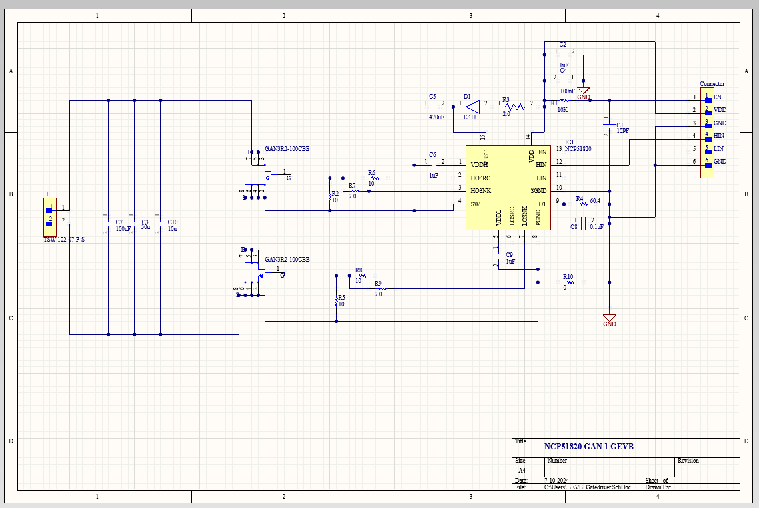
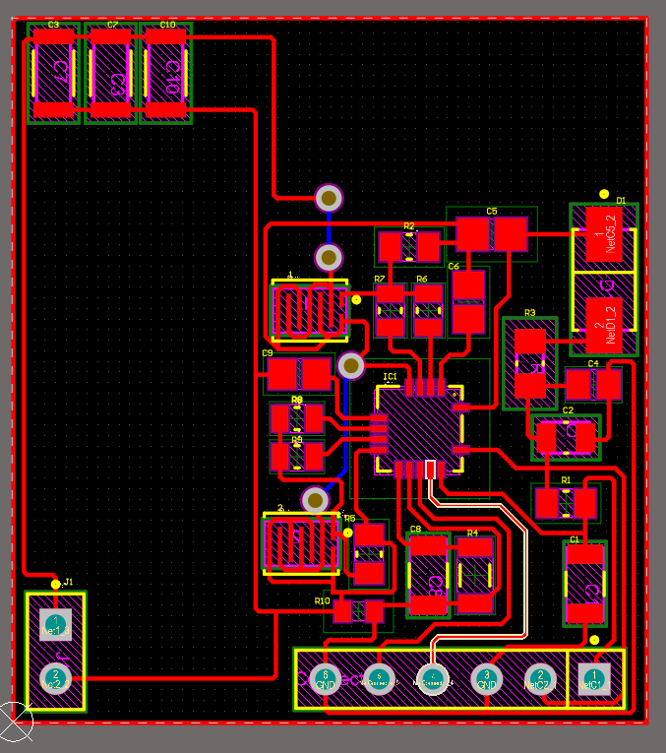
Schematic
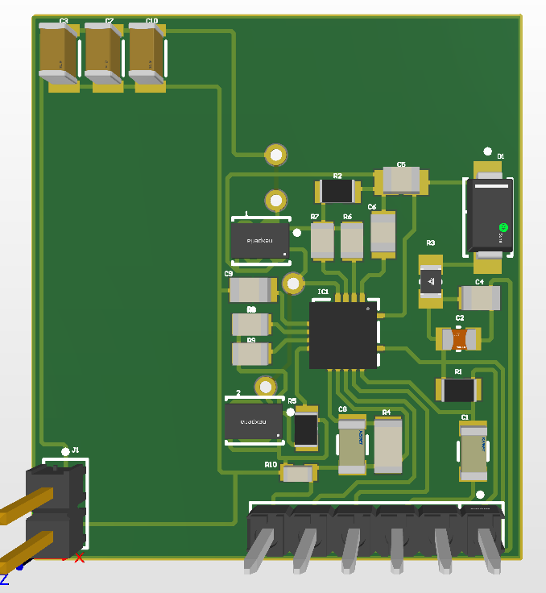

2D PCB Design 3D PCB Design

Conclusion
Power electronic converters, such as buck, boost, and flyback, are crucial in modern electrical engineering. They efficiently manage and convert electrical power across various applications, improving energy efficiency and reducing power losses. Buck converters step down voltages, boost converters step up voltages, and buck-boost converters can do both. Flyback converters allow multiple output voltages from a single input, and forward converters are suitable for high output currents. The choice of converter depends on the application's requirements, and careful selection is essential for optimal performance and energy efficiency.

References
Fundamentals of MOSFET and IGBT Gate Driver Circuits
www.ti.com/lit/ml/slua618a/slua618a.pdf?ts=1719894189069&ref_url=https%253A%252F%252Fwww.google.com%252F
GAN3R2-100CBE
https://assets.nexperia.com/documents/data-sheet/GAN3R2-100CBE.pdf
High Speed Half-Bridge Driver for GaN Power Switches NCP51820
www.onsemi.com/pdf/datasheet/ncp51820-d.pdf

